AIM
SUPPLIER INVOICE INBOUND
MD.120 deployment Instructions
Raya International Services

Author: Varun Sai Kumar Jonna
Creation Date: JUNE 05, 2024
Last Updated:
Version: 1.0

Title, Subject, Last Updated Date, Reference Number, and Version are marked by a Word Bookmark so that they can be easily reproduced in the header and footer of documents. When you change any of these values, be careful not to accidentally delete the bookmark. You can make bookmarks visible by selecting Tools->Options…View and checking the Bookmarks option in the Show region.

Approvals:
<Approver 1>
<Approver 2>
To add additional approval lines, press [Tab] from the last cell in the table above.
 Copy Number _____
You can delete any elements of this cover page that you do not need for your document. For example, Copy Number is only required if this is a controlled document and you need to track each copy that you distribute.

Document Control

Change Record
3
Date | Author | Version | Change Reference
 |  | Ver 1.0

Reviewers

Name | Position

Distribution

Copy No. | Name | Location
The copy numbers referenced above should be written into the Copy Number space on the cover of each distributed copy. If the document is not controlled, you can delete this table, the Note To Holders, and the Copy Number label from the cover page.

Note To Holders:
If you receive an electronic copy of this document and print it out, please write your name on the equivalent of the cover page, for document control purposes.
If you receive a hard copy of this document, please write your name on the front cover, for document control purposes.
Contents
Document Control iii
Creating Connections For Integration 1
- Creation Of FTP Adapter. 1
- Creation Of SOAP Adapter To Apply Receipts 5
- Creation Of SOAP Adapter To Call BI Report 6
Creating Integration 6
Run The Integration 37
Integration Tracking 39
Open and Closed Issues for this Deliverable 41
Open Issues 41
Closed Issues 41

To update the table of contents, put the cursor anywhere in the table and press [F9]. To change the number of levels displayed, select the menu option Insert->Index and Tables, make sure the Table of Contents tab is active, and change the Number of Levels to a new value.

Create Connections for APPLY AR RECEIPTS
Creation of adapters:
- To Apply AR Receipts we are using two Adapters ftp and Soap
- To create connections, navigate to connections tab and select create option then select desired adapter as shown below.
Adapter :- it helps to store the required credentials to make a connection.

Creation Of FTP :
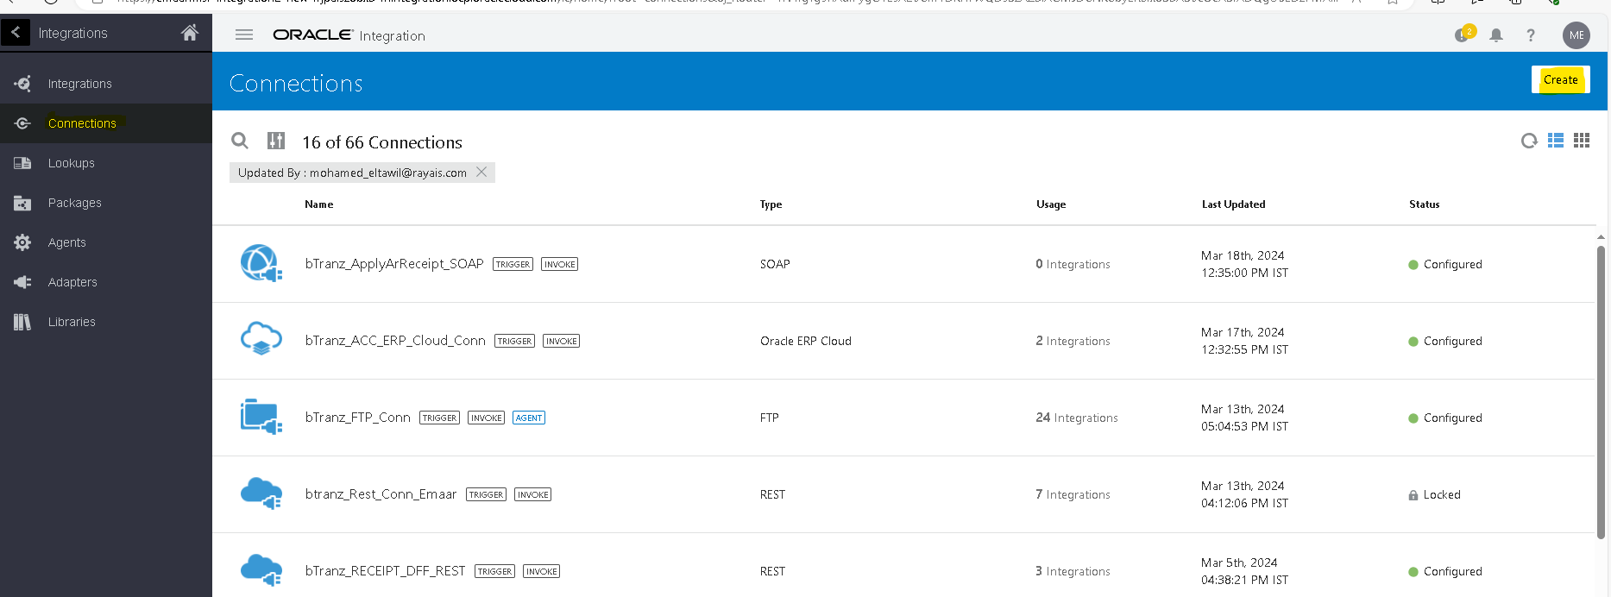
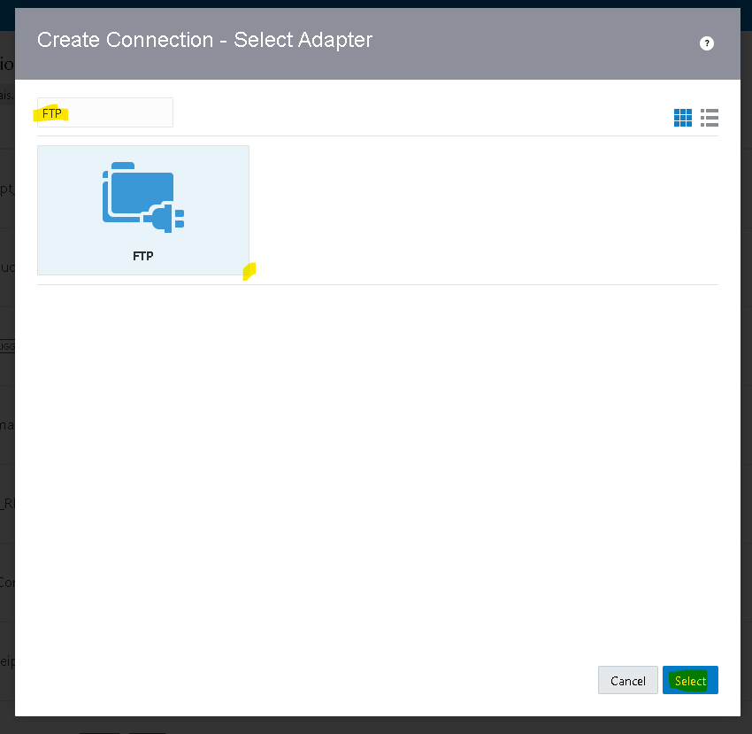
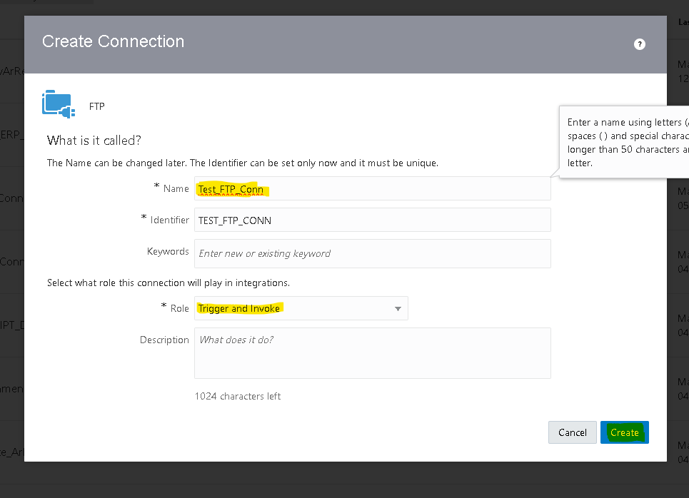

Connection Role :- a trigger means the connection where the integration receives the message. An invoke means the connection where the integration sends the message.
- Based on our requirement we choose trigger and invoke role connection.
- After clicking on create we need to pass the required Data along with the login credentials.
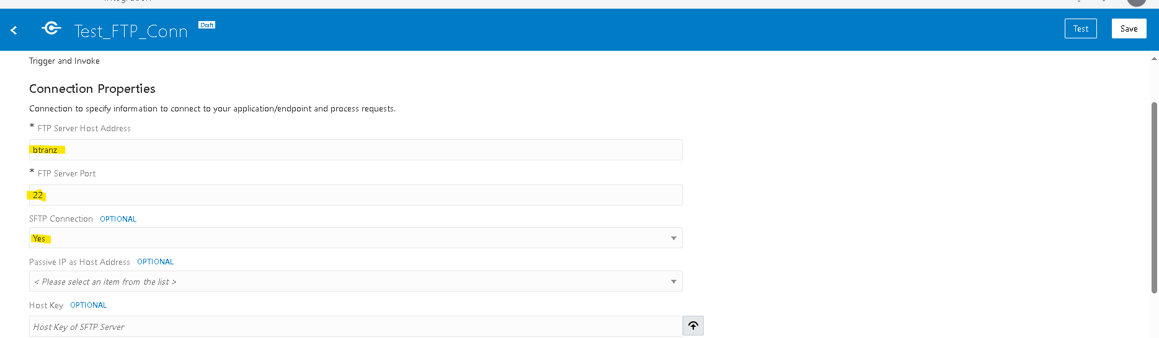
- Then click on test,popup will appear as shown above then select diagnose & test.
- After successful testing save your connection.
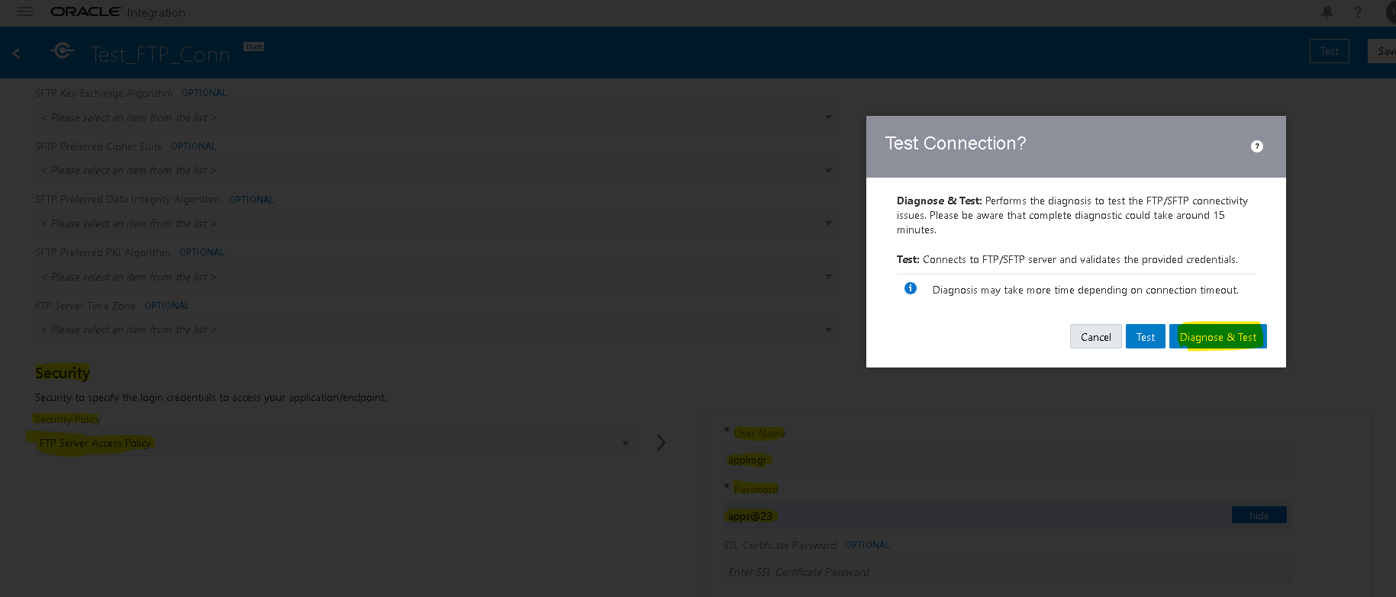
Creation Of Soap Connection For Apply AR Receipts:-
role trigger and invoke
- Navigate to connections tab then select the adapter based on the connection(SOAP)
- WSDL URL : - https://fa-ewtd-test-saasfaprod1.fa.ocs.oraclecloud.com/fscmService/StandardReceiptService?WSDL.
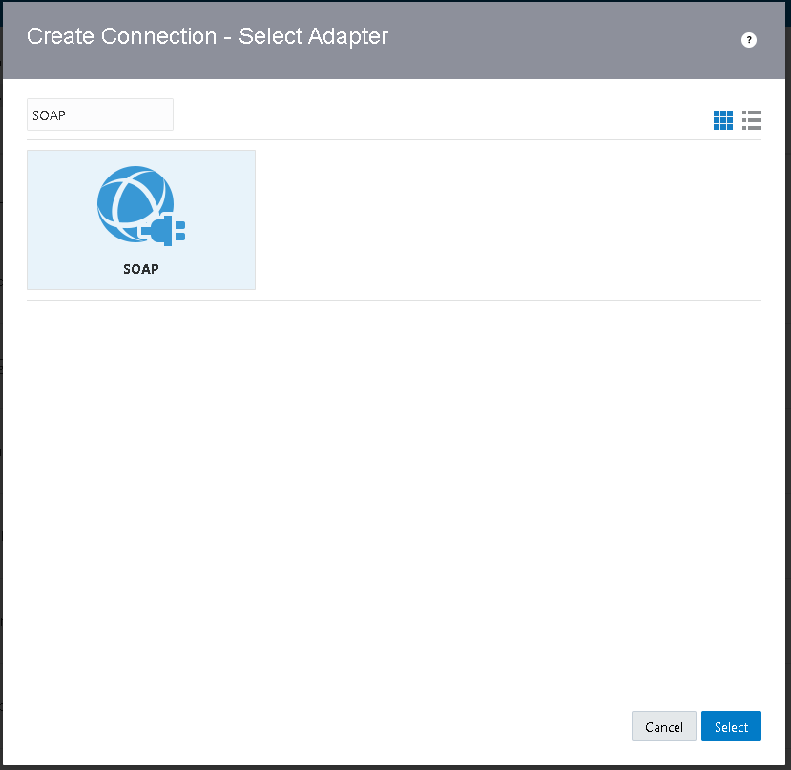
- Enter the WSDL URL and select security as basic authentication and enter fusion credentails as username and password.
- Then click on test, after testing successfully save the connection.
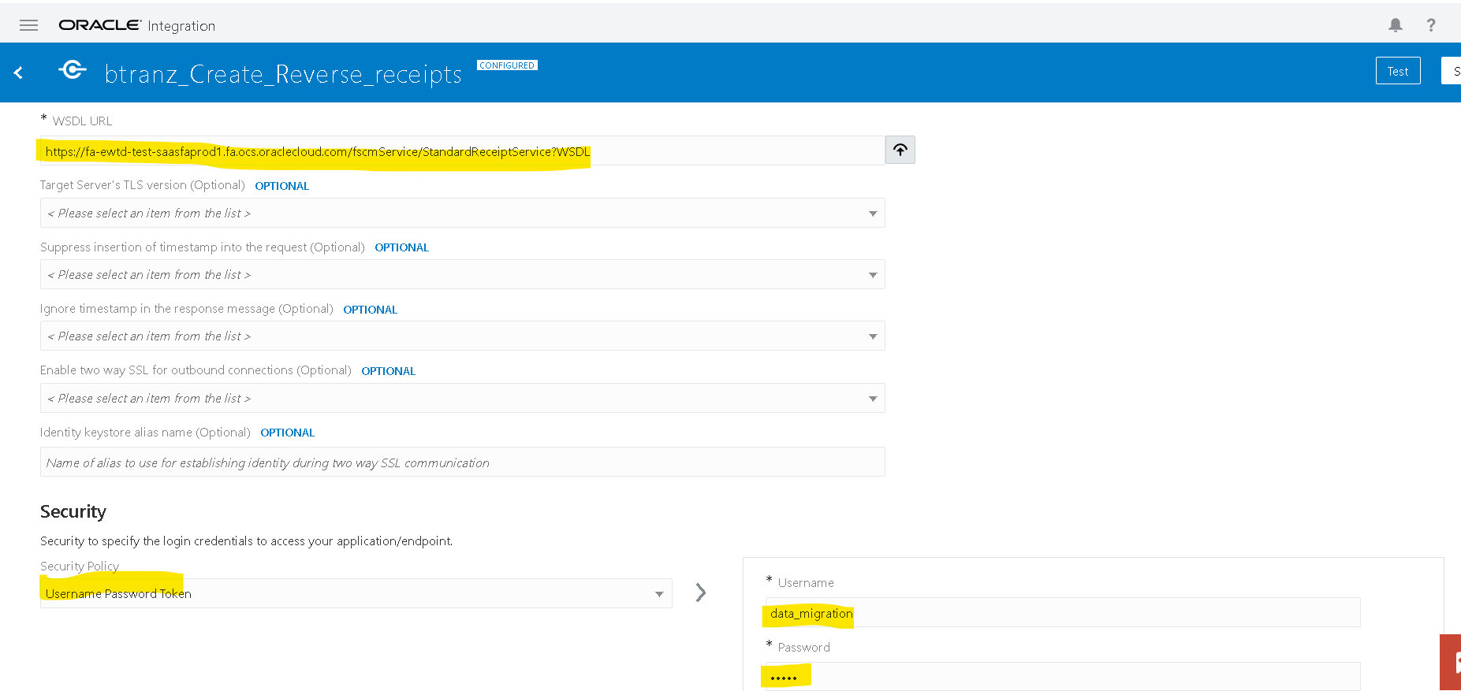
Creation of soap connection For Calling BI report :-
- For Create Reverse Receipts we are calling the BIP Report to get Fusion ReceiptID and Fusion TransactionID by passing EBS ReceiptID and TransactionID as parameter.
- We need to create another SOAP connection to call BI report.
- WSDL URL :- https://fa-ewtd-test-saasfaprod1.fa.ocs.oraclecloud.com/xmlpserver/services/ExternalReportWSSService?wsdl.
- Enter the WSDL URL and select security as basic authentication and enter fusion credentails as username and password.
- Then click on test, after testing successfully save the connection.
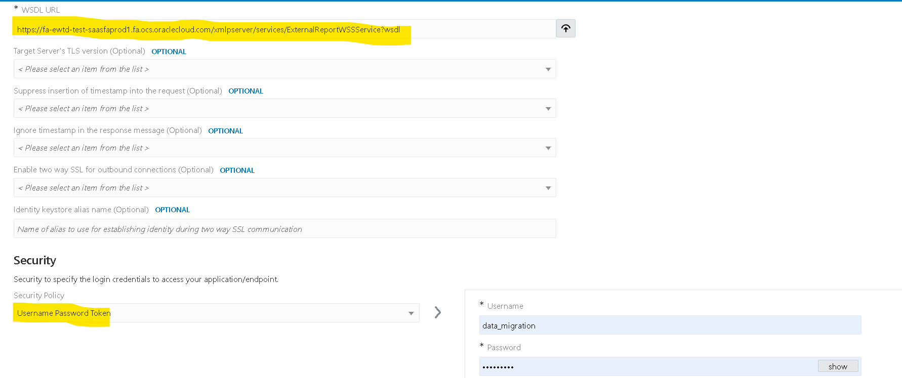
Creation Of Integration:
- Navigate to integration tab then click on create option and select scheduled orchestration.
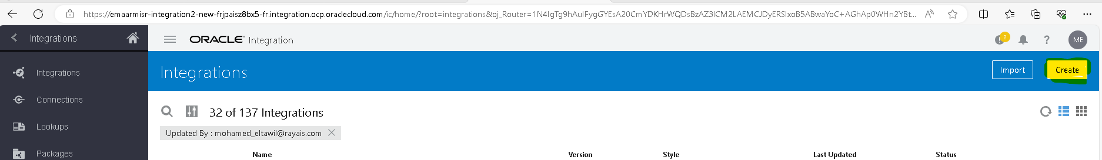
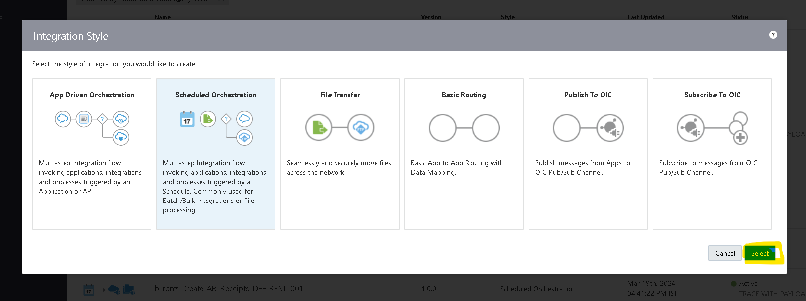

- Try to create with a unique name for identification.
- Once the integration is created select the action button on the right side of the Tab.
- Drag the Assign action and place it on plus (+) icon in the integration.
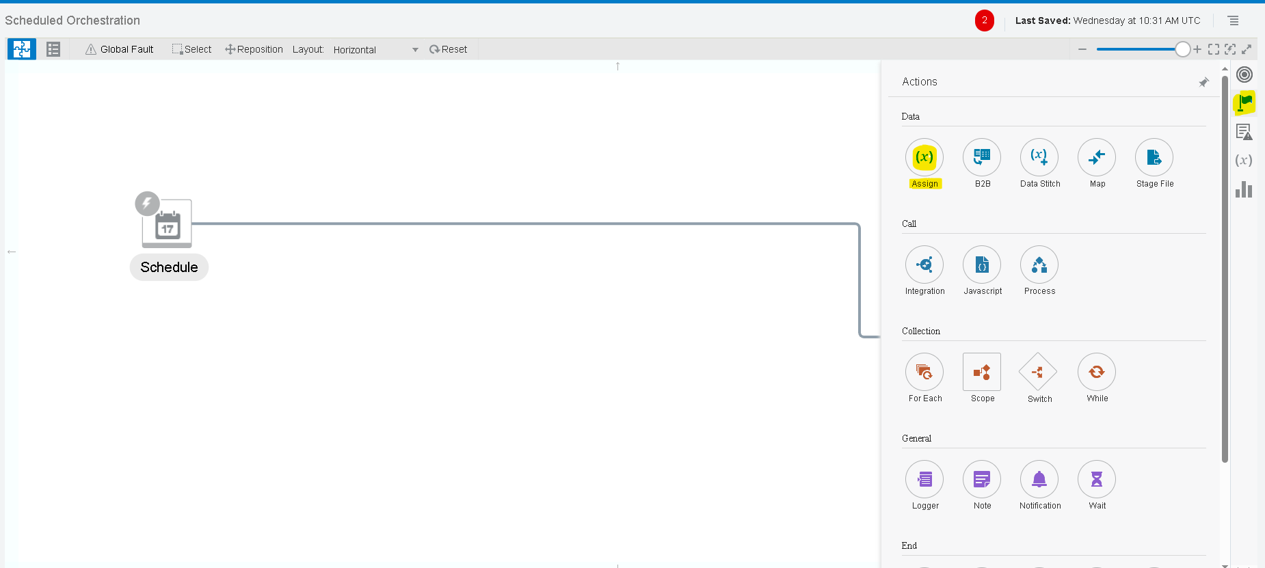
- Give a name for the assign action and click on create.
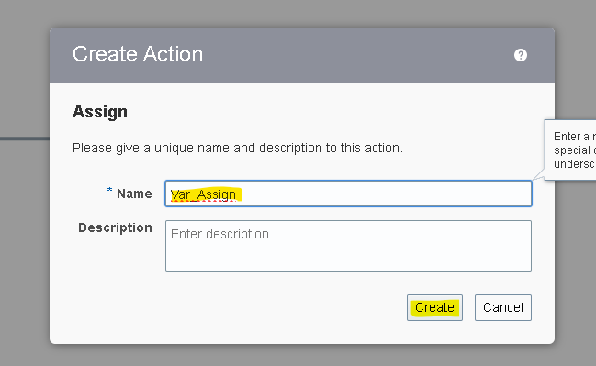
- Give the name of the variable and click on the pencil icon to assign the value for the variable.
- To add one more variable you can select plus (+) icon.
Note :- To Assign/Mention The Values We Need To Use Single Quotes .

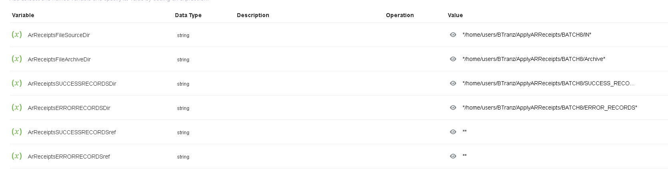
- Here we created six variables.

- ArReceiptsFileSourceDir : To store the source file directory.
- ArReceiptsFileArchiveDir : To store the Archive file directory.
- ArReceiptsERRORRECORDSDir : To Store the Error records directory.
- ArReceiptsSUCCESSRECORDSDir : To Store the Success records directory.
- ArReceiptsSUCCESSRECORDSref : To Store the Success records Data.
- ArReceiptsERRORRECORDSref : To Store the Error records Data.

- Select the Plus (+) Icon and select the FTP adapter which we created earlier.
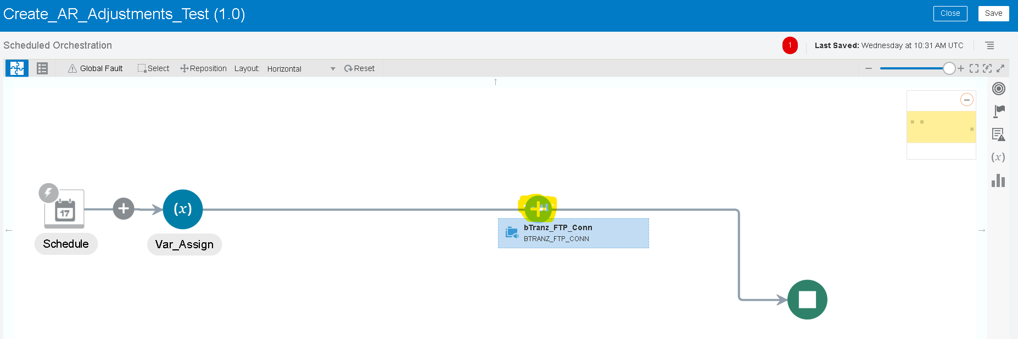

- Name the ftp connection appropriate to your integration for better understanding. As we are listing the number of files in source dir, so we used the List_Files operation.

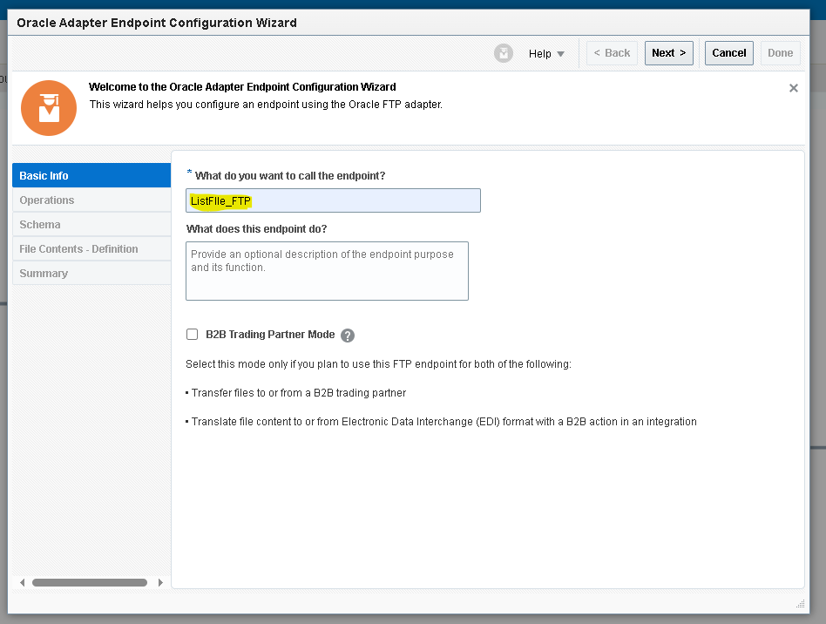
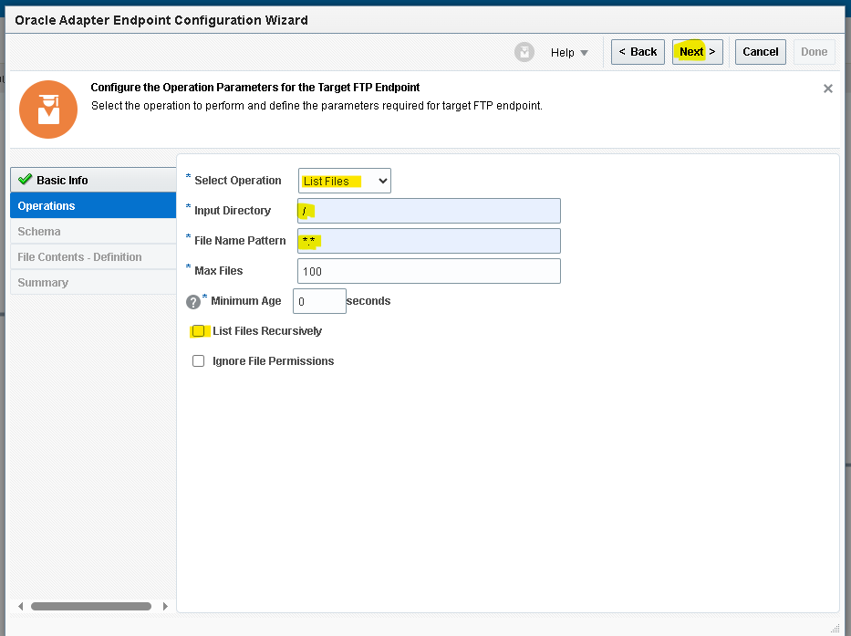
- Since we are using variables for input directory, temporarily mentioned ‘/’ and’ *’ symbols.

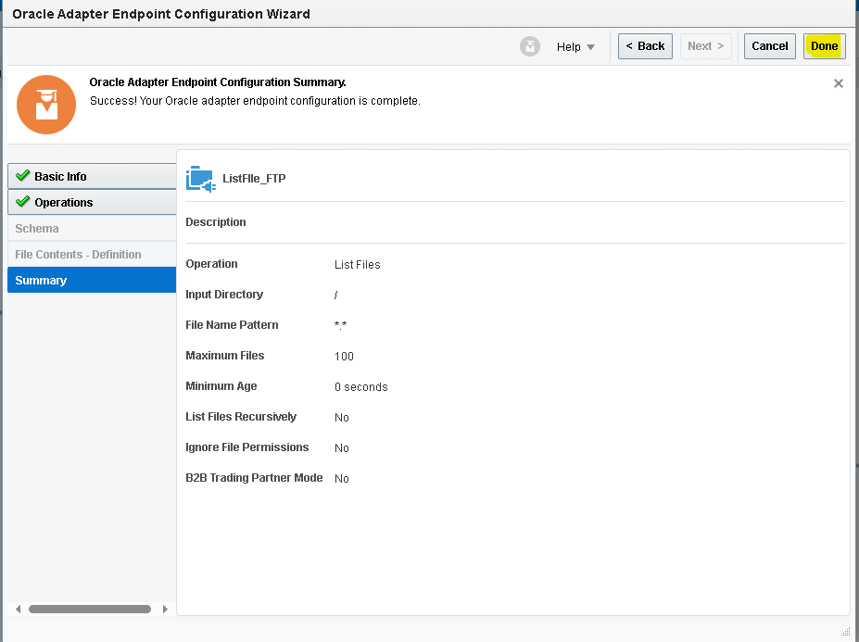
- Then it will create a mapper for ListFile_FTP.
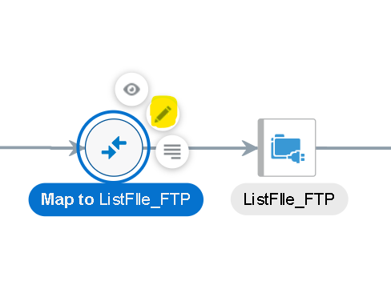
- We need to map the data for the list operation as a request.
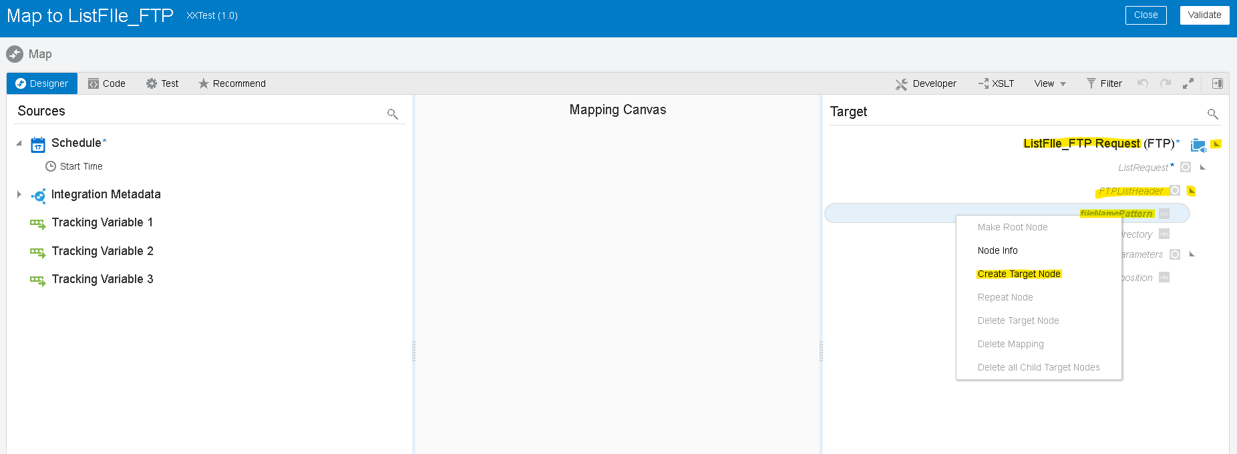
- We need to create a target node if we need to map the data manually as per our requirement.
- Here we are listing every file from the directory so we will use asterisk (*) for the FileNamePattern using single quotes as shown below
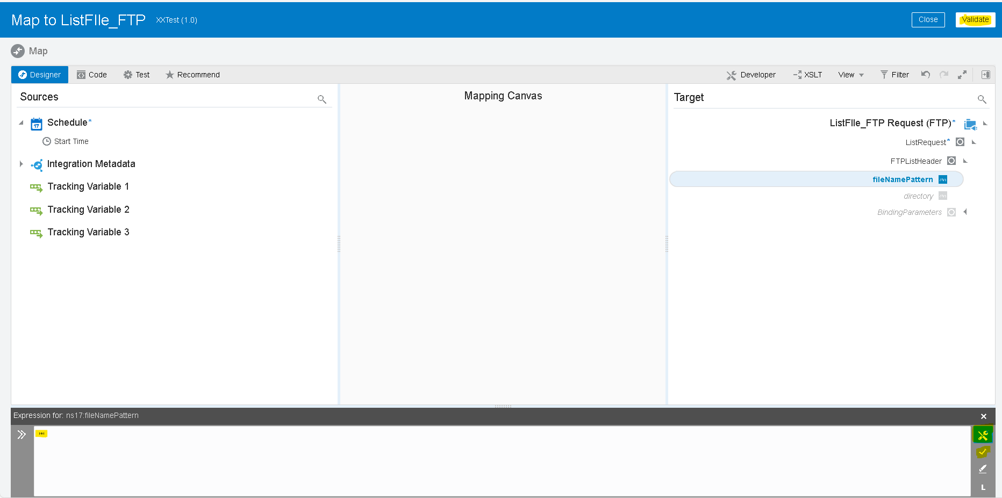

- For the source file directory we will map the variable which we created before by dragging left to right and click on validate.
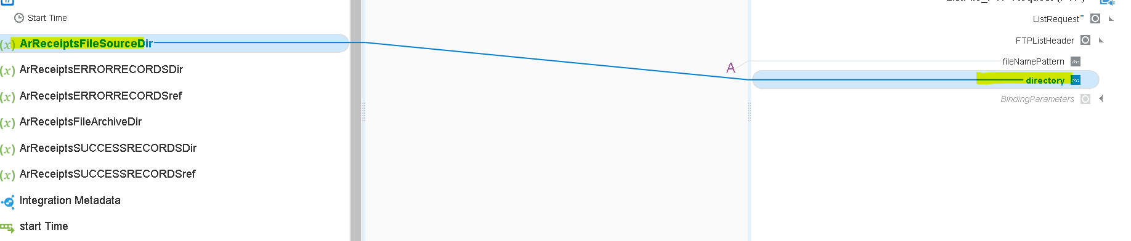
- Now we are using switch operation to check whether file exists or not in the listed directory.
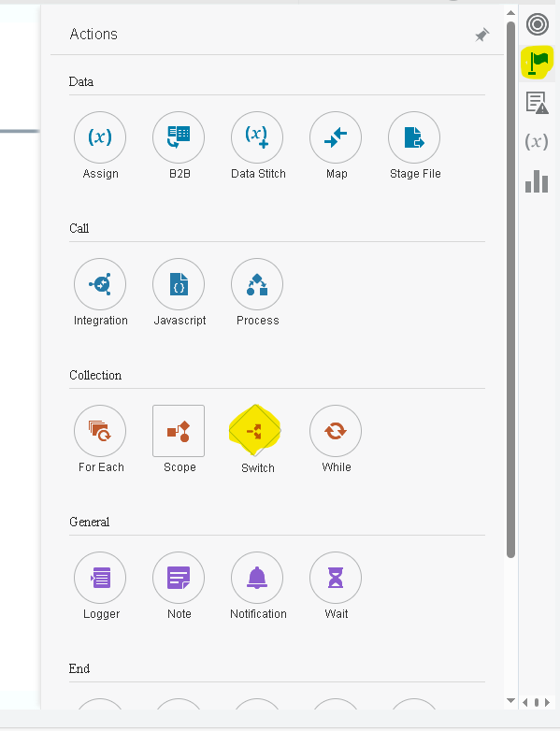
- Once you drag the switch operation on the plus (+) icon
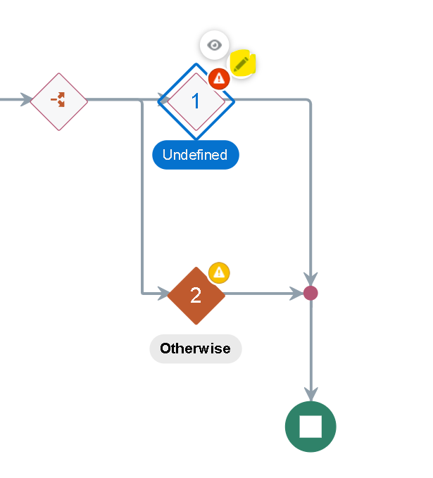
- We will use the response of the ListFile operation using ItemCount.
- Drag the ItemCount from the ListResponse to the switch condition as shown below.

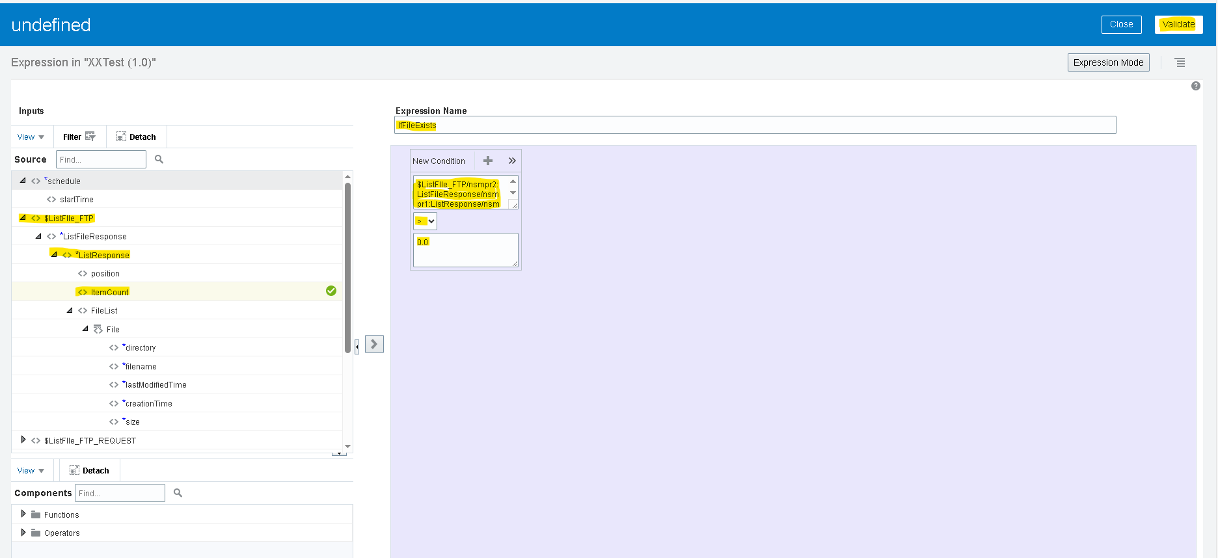

- Now we need to use ‘For Each’ action as we need to iterate each file.
- Click on plus (+) icon and search ‘For Each’ as shown below.
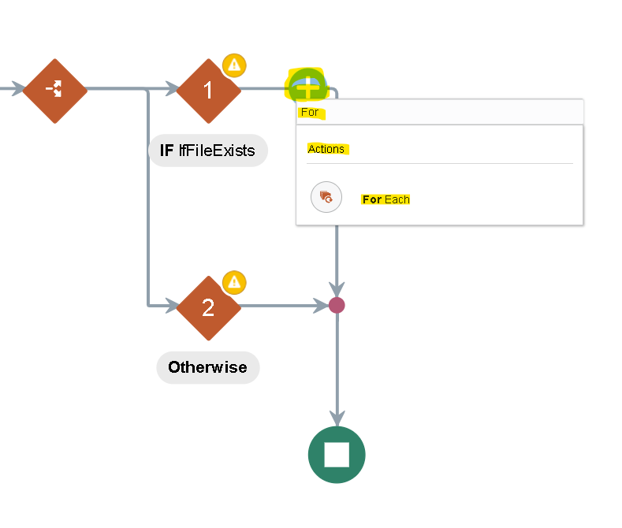
- We will use the repeating element as the file which we got as a response from the list file operation.
- Drag the file to the repeating element and click on create.
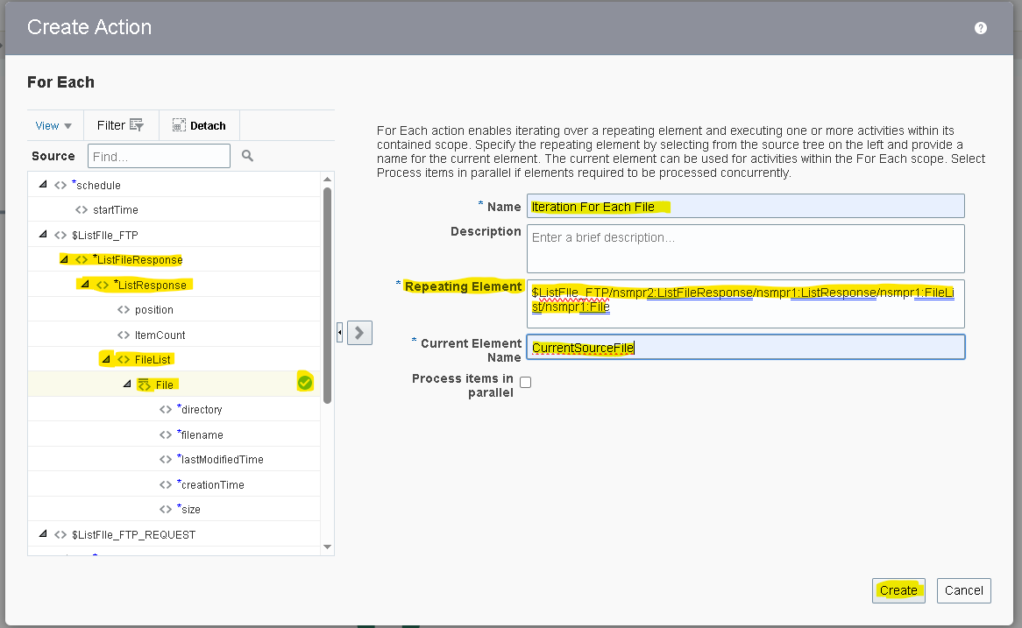

- Scope : - it is a logical container or grouping mechanism used to organize and control the flow of integration components and actions within an integration.
- We need to add a scope as we can handle any errors within scope without disturbing whole integration.
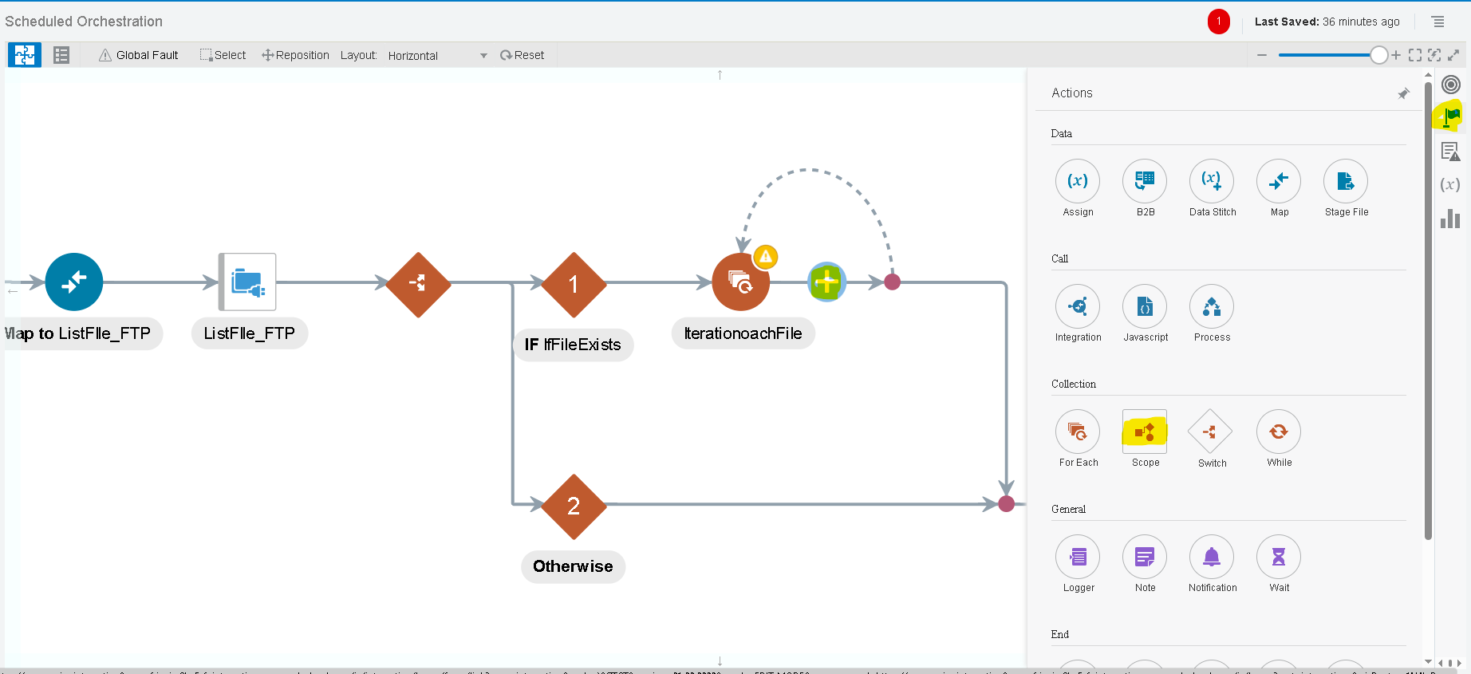
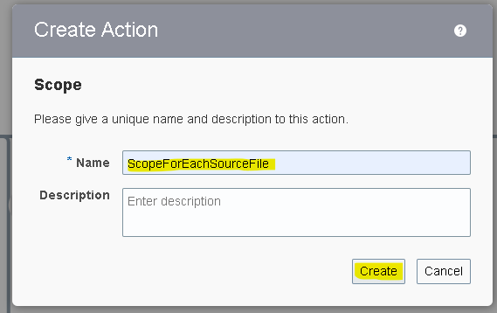
- Within the scope we are using download operation of the ftp connection.
- The download operation allows us to download the file in OIC logical directory. It is the virtual directory which can only be used within that integration.
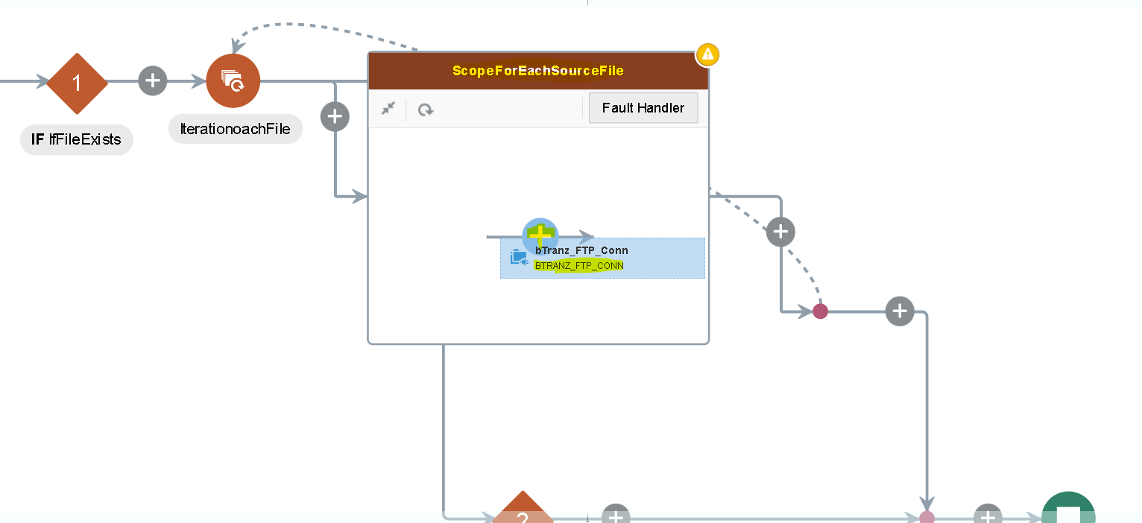
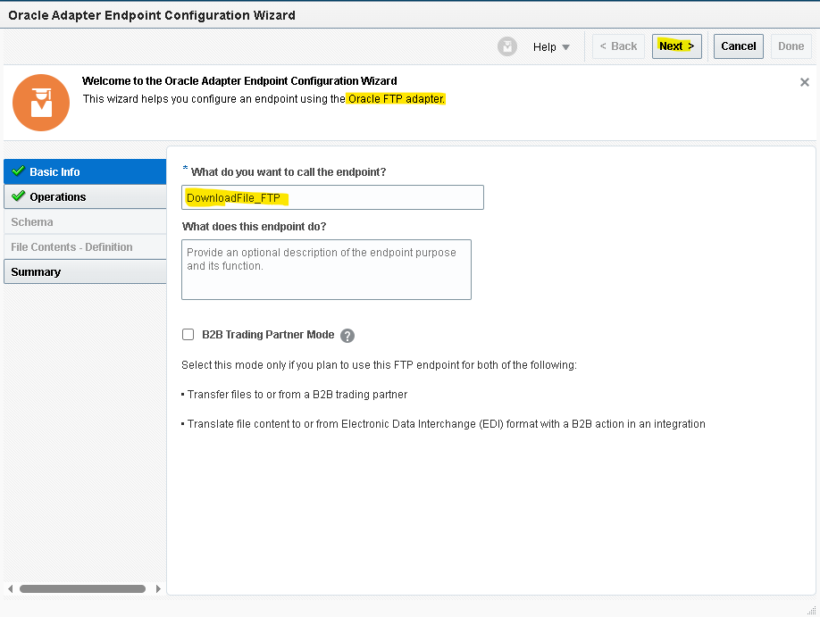

- We will map the input directory and file name later with the response of the ForEach. As of now we are assigning it.
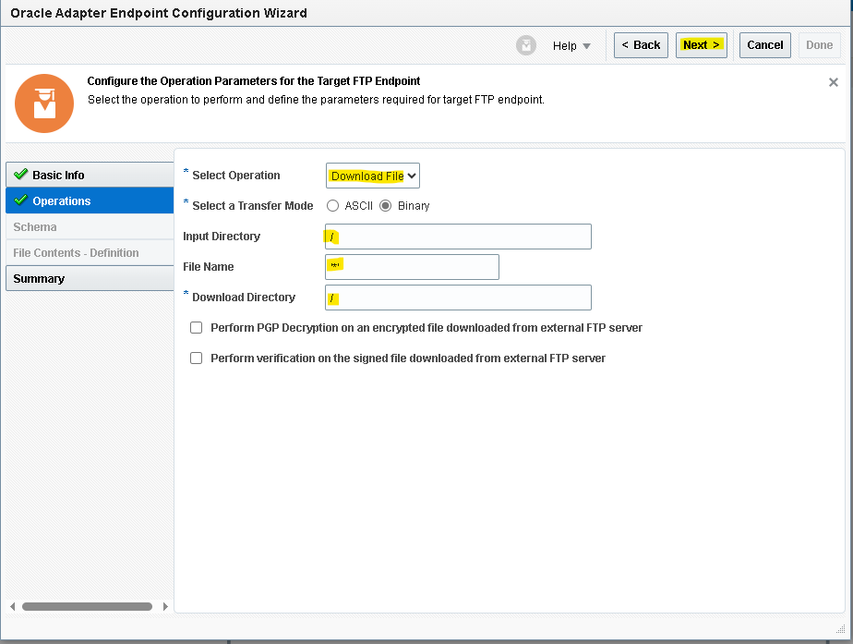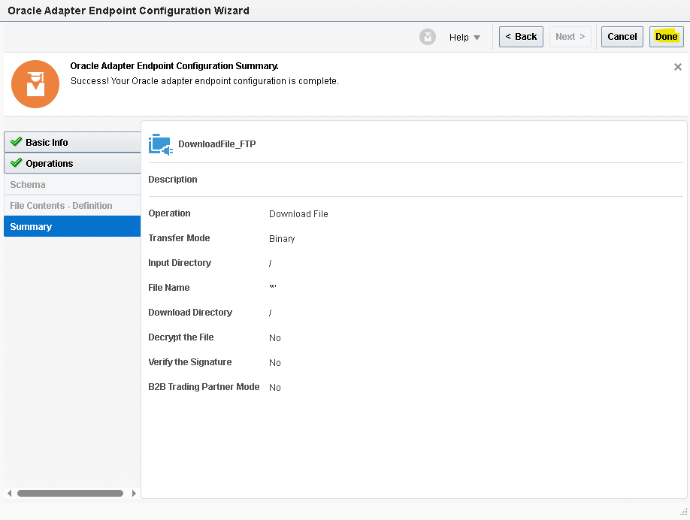
- Click on edit icon on the mapper of the download file operation and map the values.
- For the file name and the directory we are using the current source file which is the ForEach response.
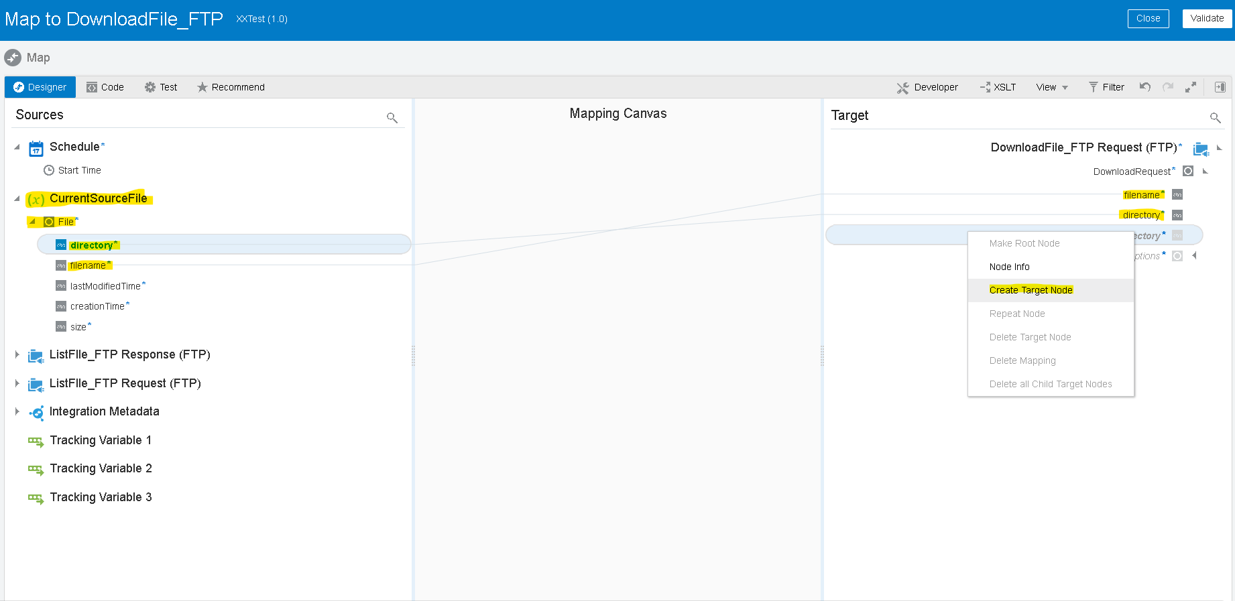

- For download directory (OIC logical directory) we are using the filename .here we are using the substring before function to remove the .extension and returns only file name.
- Drag the substring option from the toggle function option from the top right corner as shown above
- Drag the filename from the current source file and hardcode the mapper as it returns the string before the dot (.) And then validate.

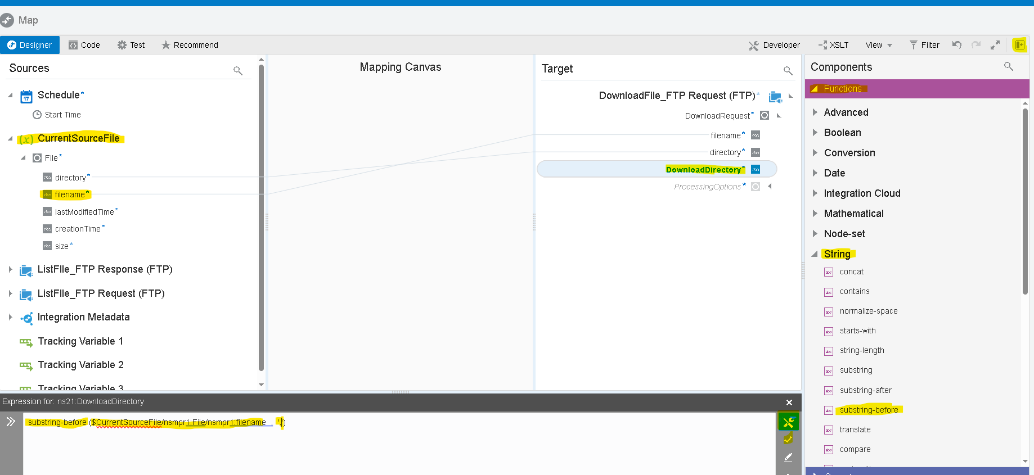
- Now we will use the stage activity to read the file from the response of the Download_Ftp.
- Search for ‘stage’ adapter by clicking on the plus (+) icon.
- Select the operation as ‘read File In Segments’. And configure file reference as yes.
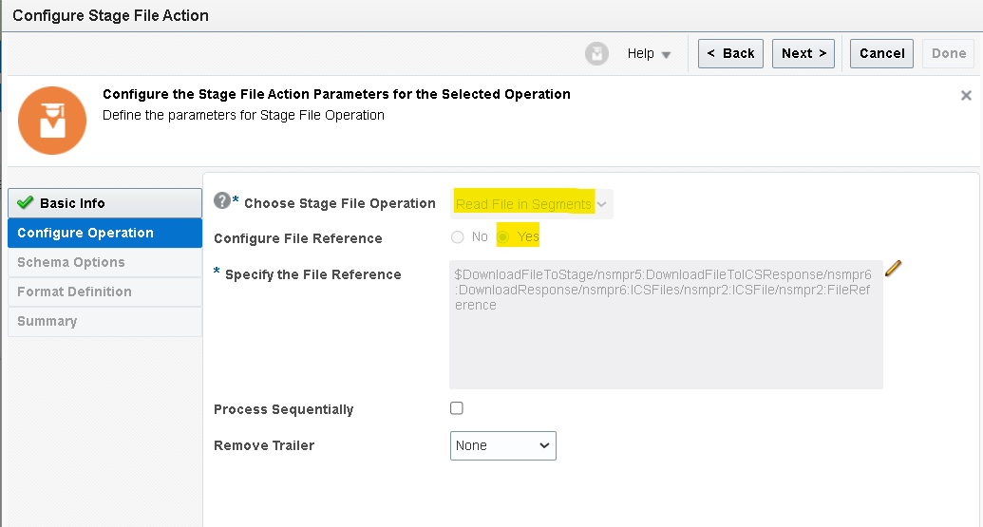
- Now we need to give the structure of the file content. As we are using the csv file select reference file from download response.

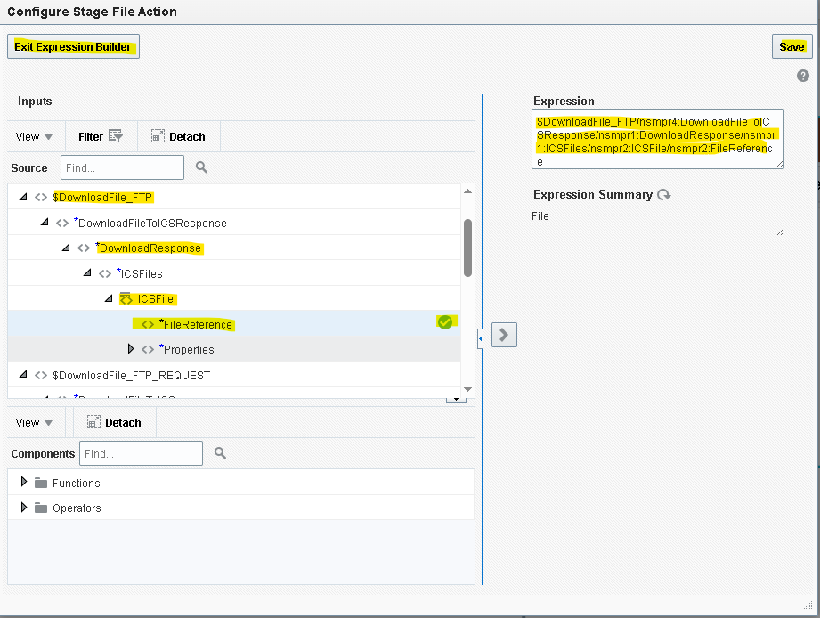
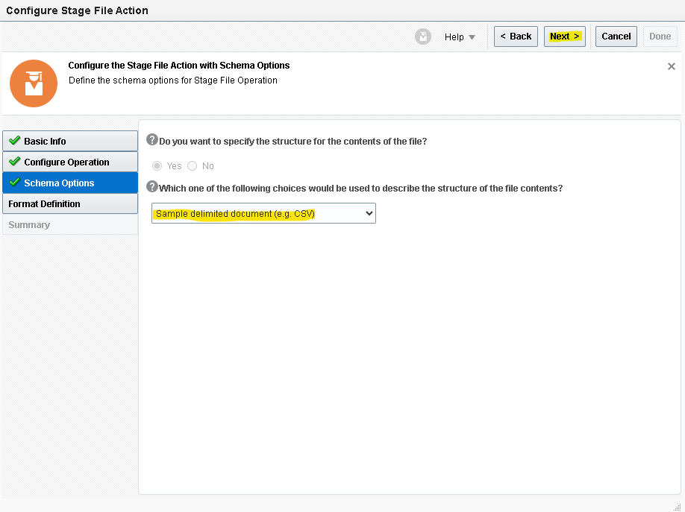
- We need to give sample structure format of the file which we will be downloaded from the ftp.
- Here choose the file from your local desktop and you can mark all as optional but at least one column should be mandatory.
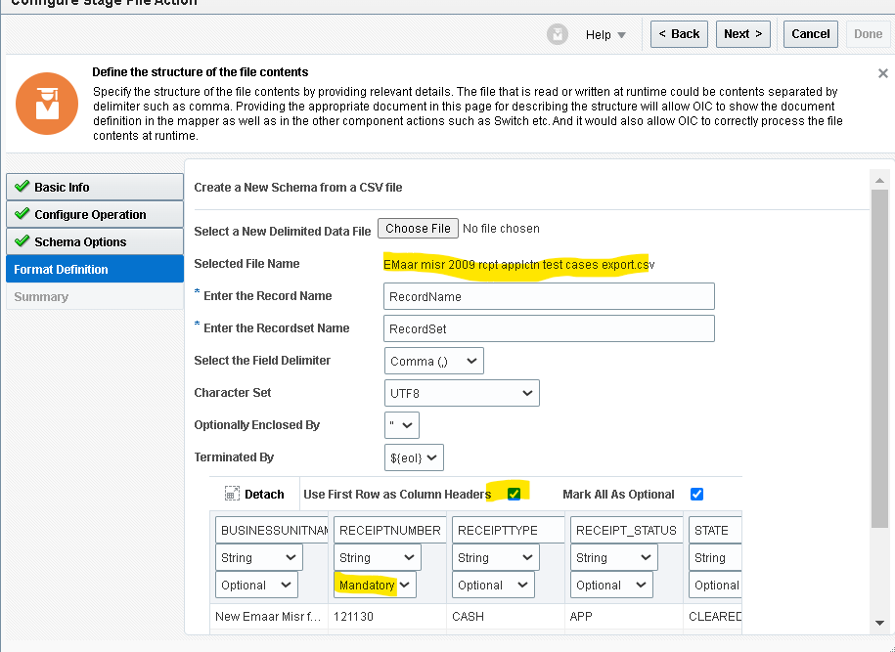
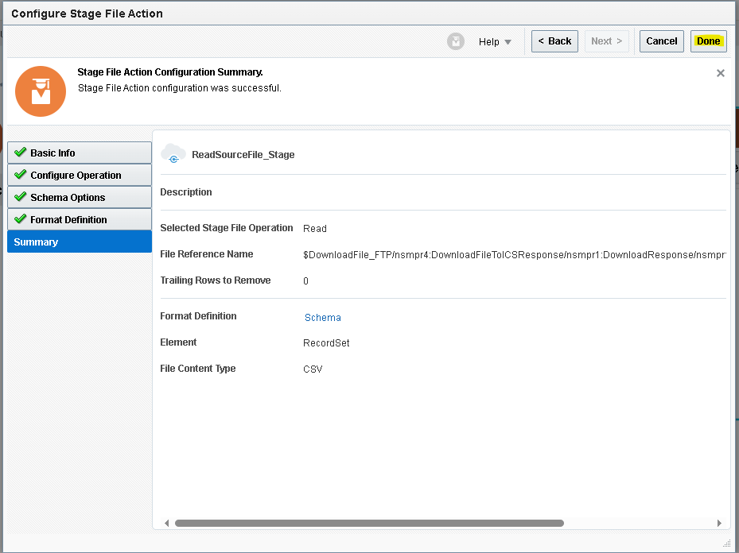

Since we need to get Fusion Transaction ID based on EBS Transaction ID which is stored in Attribute4 in ra_customer_trx_all rcta table.
- Create BIP report in Fusion with given data model. Which will take multiple EBS_trx_id values as input and gives Fusion_trx_id, Ebs_trx_id,Org_id,trx_number as response.

SOURCE CODE:

SELECT
rcta.customer_trx_id AS fusion_trx_id,
tab1.ebs_trx_id,
rcta.org_id,
rcta.trx_number
FROM
ra_customer_trx_all rcta,
(
SELECT
TRIM(regexp_substr(:p_ebs_trx_id, '[^,]+', 1, level)) ebs_trx_id
FROM
dual
CONNECT BY
regexp_substr(:p_ebs_trx_id, '[^,]+', 1, level) IS NOT NULL
) tab1
WHERE
1 = 1
AND rcta.org_id IN (
300000007131586,
300000007131567,
300000007131548
)
AND rcta.attribute4 = tab1.ebs_trx_id
GROUP BY

tab1.ebs_trx_id,
rcta.customer_trx_id ,
rcta.org_id,
rcta.trx_number

- Search for SOAP adapter to call BI report by clicking on the plus (+) icon.
- Select Operation as Run Report click on next.
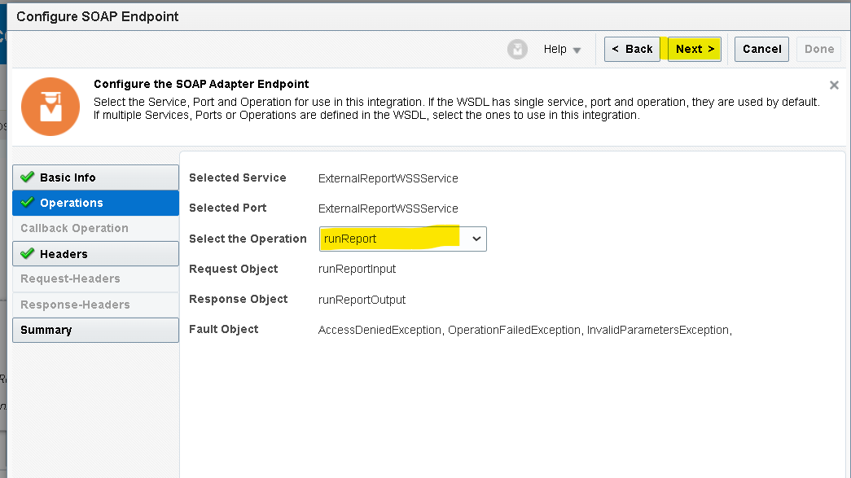
- Check the details in the summery and click on Done.
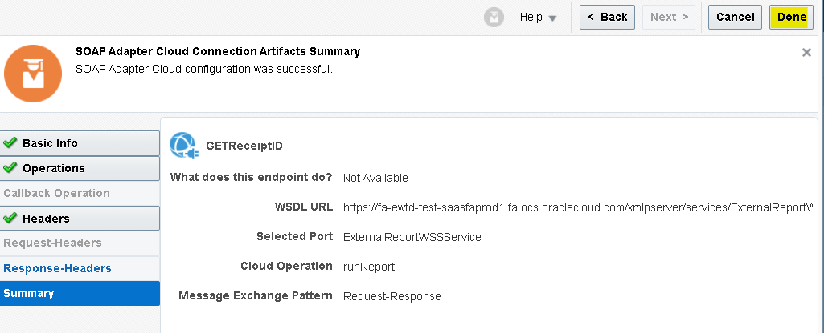
- Mapper will be created for SOAP adapter to call the BIP report edit the mapper and hardcode the mandatory fields.
- Attribute Format : Format of BI report output “CSV”
- Report Absolute Path : Location path where the BI report is saved.
- Size Of Data Chunk Download : Since our response will be less than 10 MB it will be ‘-1’
- Name and values : Enter the name of the parameter and Map the value for
that parameter from the read file response.
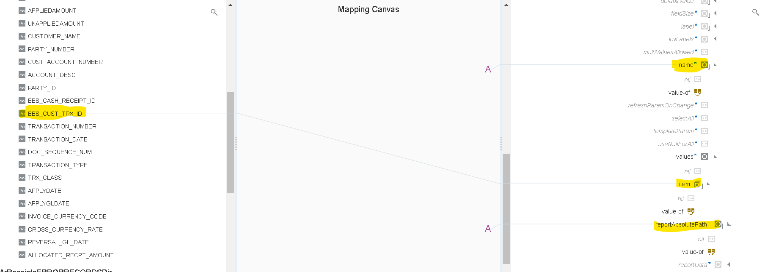
- Click on the code tab on top and add separator="," operator in XSLT code of item to read more than one value as input.
- Once you enter click on Validate and close.
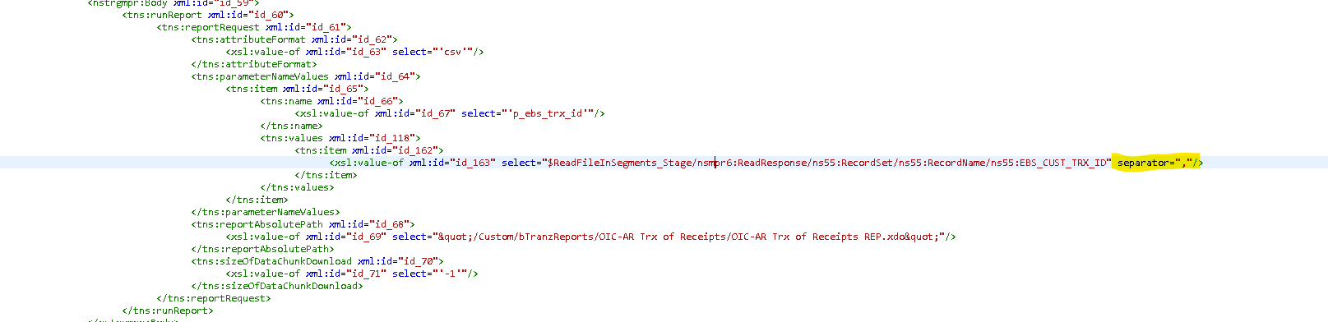
- Now we need to store the response from BI report by using stage adapter.
- Search for ‘stage’ adapter by clicking on the plus (+) icon.
- Select the operation as ‘WriteFile’. Specify the file name and output directory to store the file temporarily.
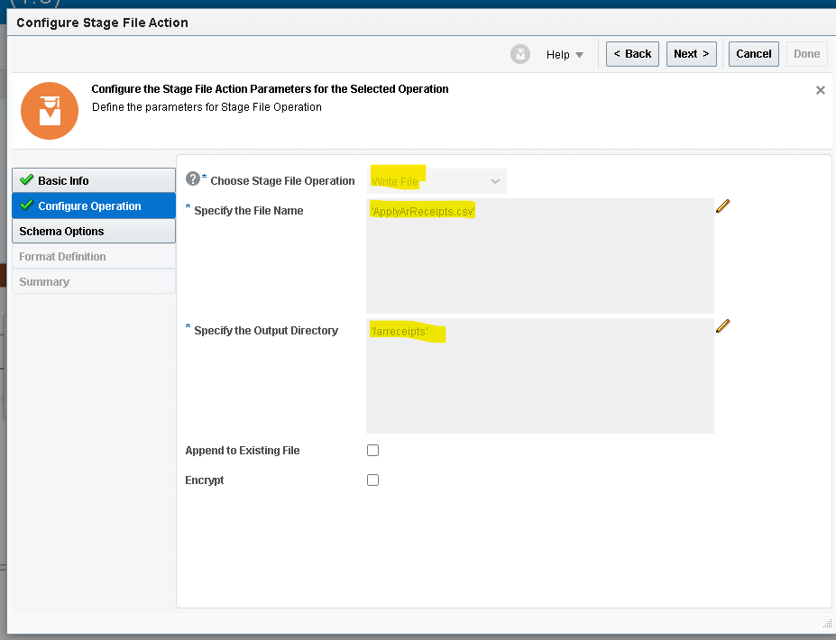

- We will get the response in base64 format so we used opaque schema to get the response from BI report.
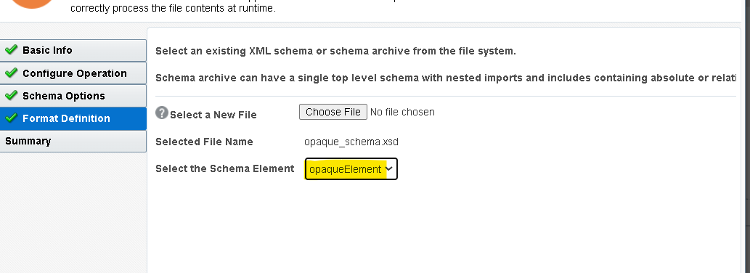
- Check the summary and click on Done.
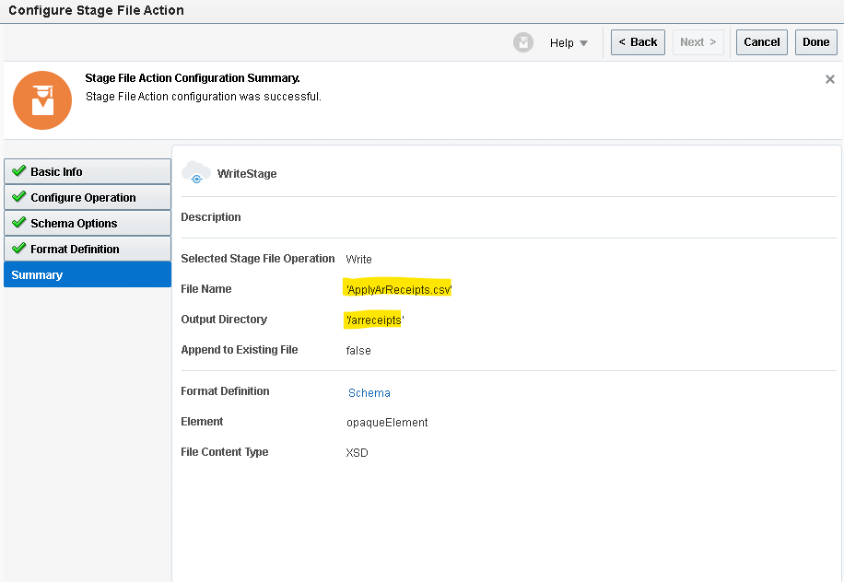
- Edit the mapper of stage write File map the report bytes from soap response the opaqueElement.
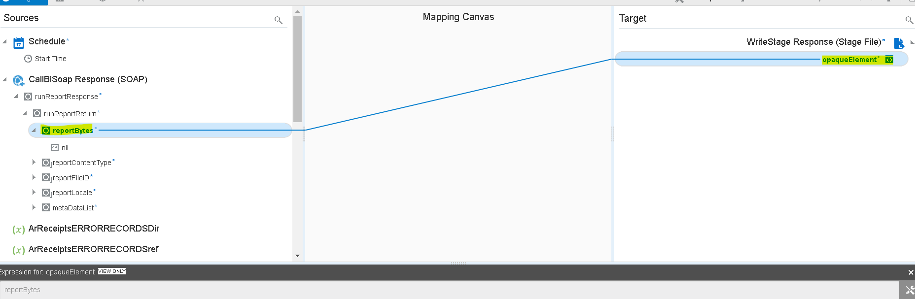
- Now we will use the stage activity to read the file from the response of the Download_Ftp.
- Search for ‘stage’ adapter by clicking on the plus (+) icon.
- Select the operation as ‘Read Entire File’. And configure file reference as yes.
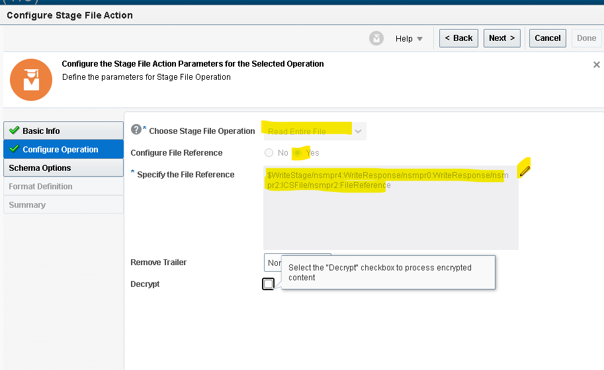

- Now we need to give the structure of the file content. As we are using the csv file select reference file from Write File response.
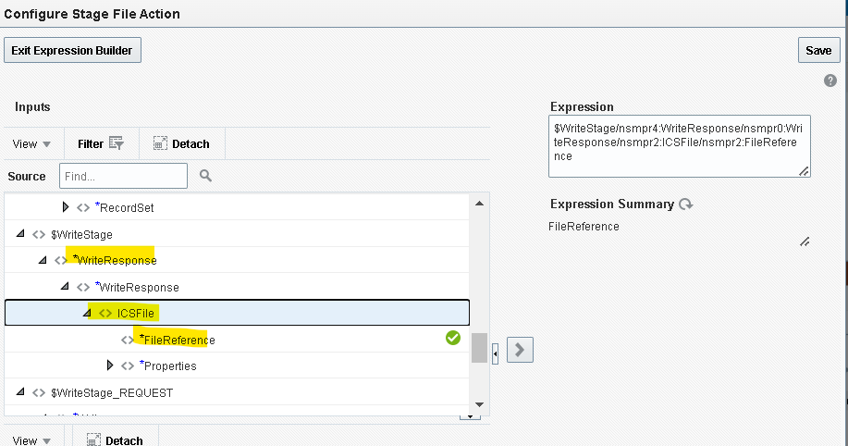
- We need to give sample structure format of the file which we will be report output format.
- Here choose the file from your local desktop and you can mark all as optional but at least one column should be mandatory.
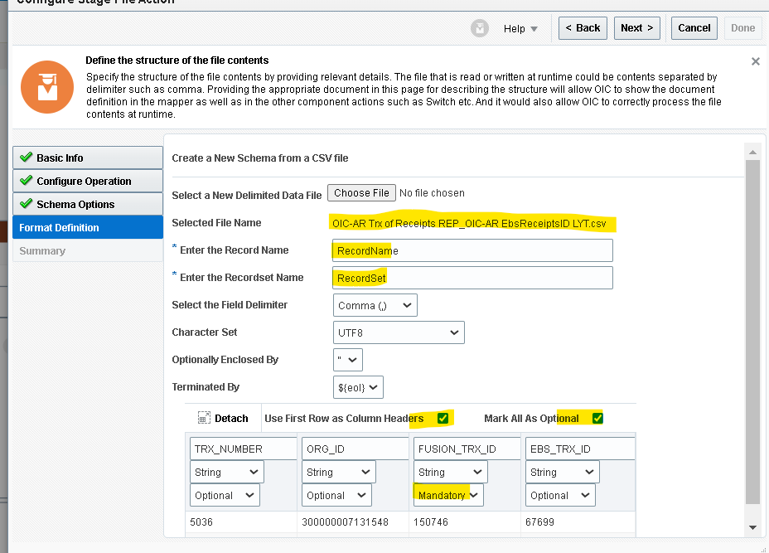
- Check the summery details and click on Done.
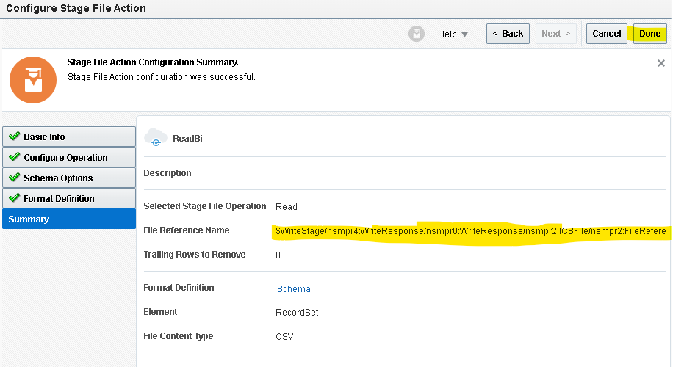

- Since we need to get Fusion Receipt ID based on EBS Receipt ID which is stored in Attribute9 in ar_cash_receipts_all acra table.
- Create BIP report in Fusion with given data model. Which will take multiple EBS_Receip_id values as input and gives Fusion_Receipt_id, Ebs_Receipt,Org_id as response.

SOURCE CODE:
SELECT
acra.cash_receipt_id AS fusion_receipt_id,
tab1.ebs_receipt_id,
acra.org_id

FROM
ar_cash_receipts_all acra,
(
SELECT
TRIM(regexp_substr(:p_ebs_receipt_id, '[^,]+', 1, level)) ebs_receipt_id
FROM
dual
CONNECT BY
regexp_substr(:p_ebs_receipt_id, '[^,]+', 1, level) IS NOT NULL
) tab1
WHERE
1 = 1
AND acra.org_id IN (
300000007131586,
300000007131567,
300000007131548
)
AND acra.attribute9 = tab1.ebs_receipt_id
AND acra.receipt_number NOT LIKE '%E+%'
group by
acra.cash_receipt_id ,
tab1.ebs_receipt_id,
acra.org_id

- Search for SOAP adapter to call BI report by clicking on the plus (+) icon.
- Select Operation as Run Report click on next.

- Check the details in the summery and click on Done.

- Mapper will be created for SOAP adapter to call the BIP report edit the mapper and hardcode the mandatory fields.
- Attribute Format : Format of BI report output “CSV”
- Report Absolute Path : Location path where the BI report is saved.
- Size Of Data Chunk Download : Since our response will be less than 10 MB it will be ‘-1’
- Name and values : Enter the name of the parameter and Map the value for
that parameter from the read file response.
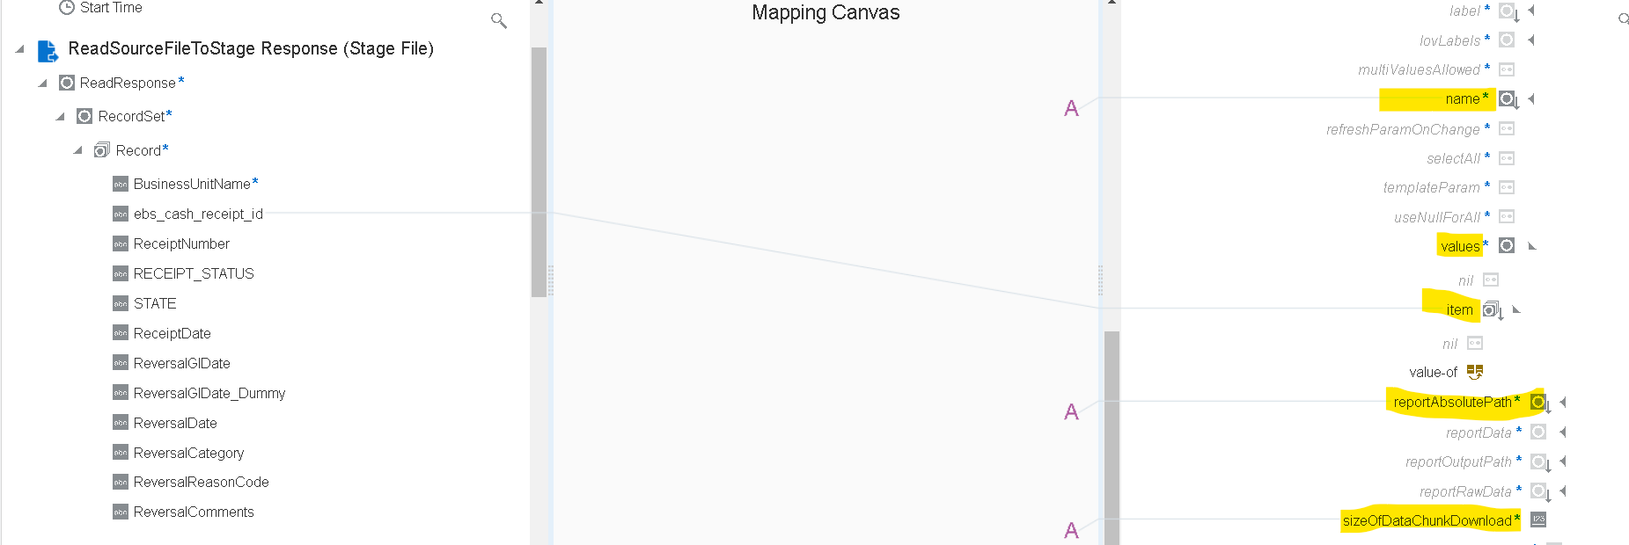
- Click on the code tab on top and add separator="," operator in XSLT code of item to read more than one value as input.
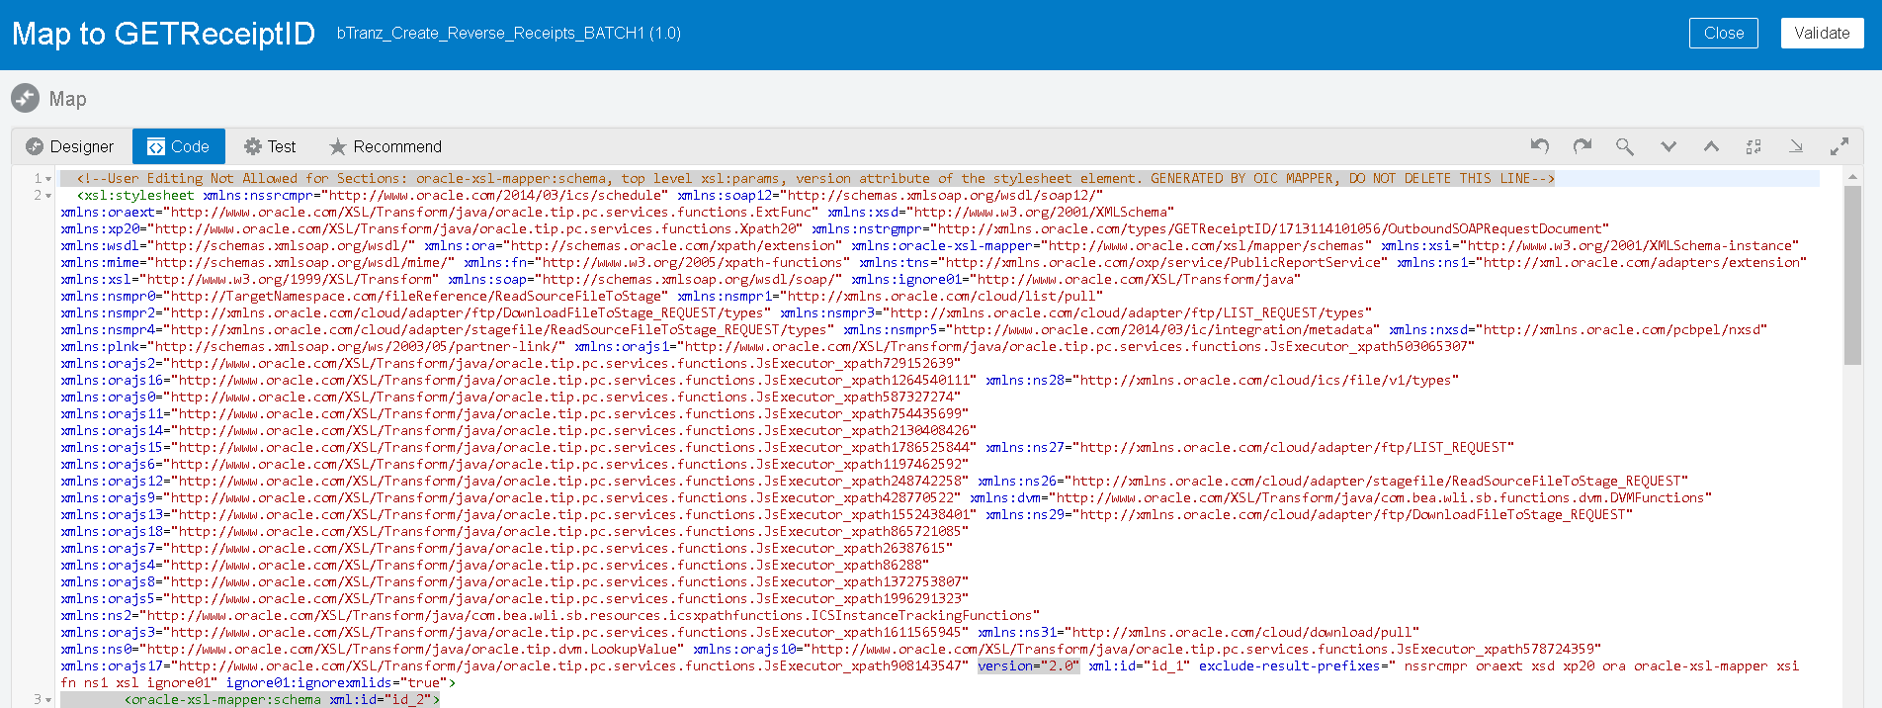

- Once you enter click on Validate and close.
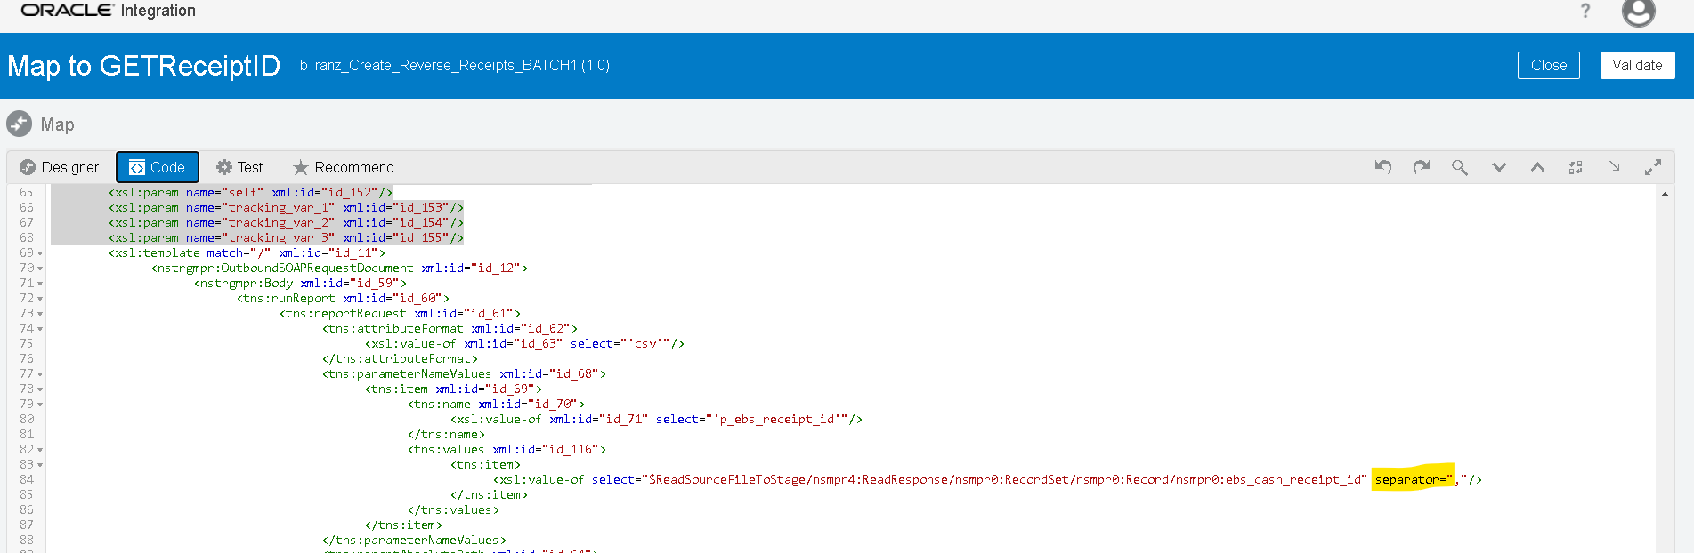

- Now we need to store the response from BI report by using stage adapter.
- Search for ‘stage’ adapter by clicking on the plus (+) icon.
- Select the operation as ‘WriteFile’. Specify the file name and output directory to store the file temporarily.
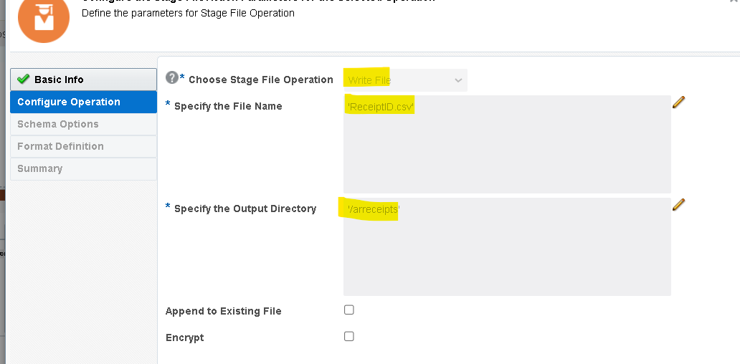

- We will get the response in base64 format so we used opaque schema to get the response from BI report.

- Check the summary and click on Done.
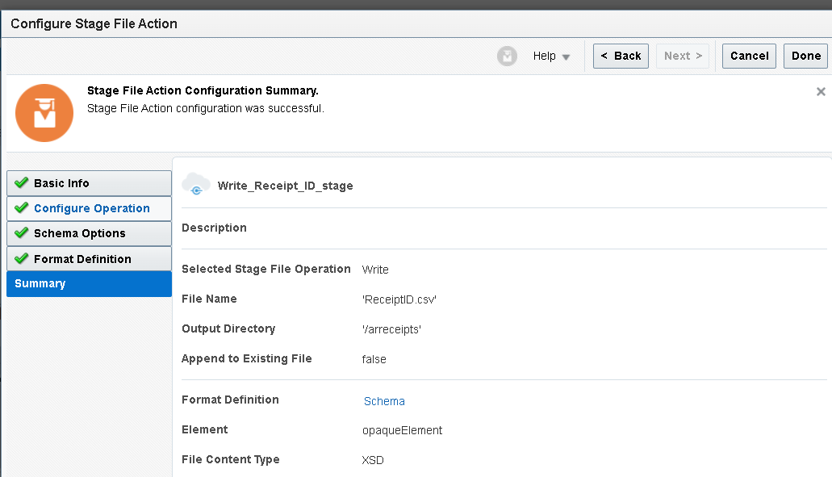
- Edit the mapper of stage write File map the report bytes from soap response the opaqueElement.
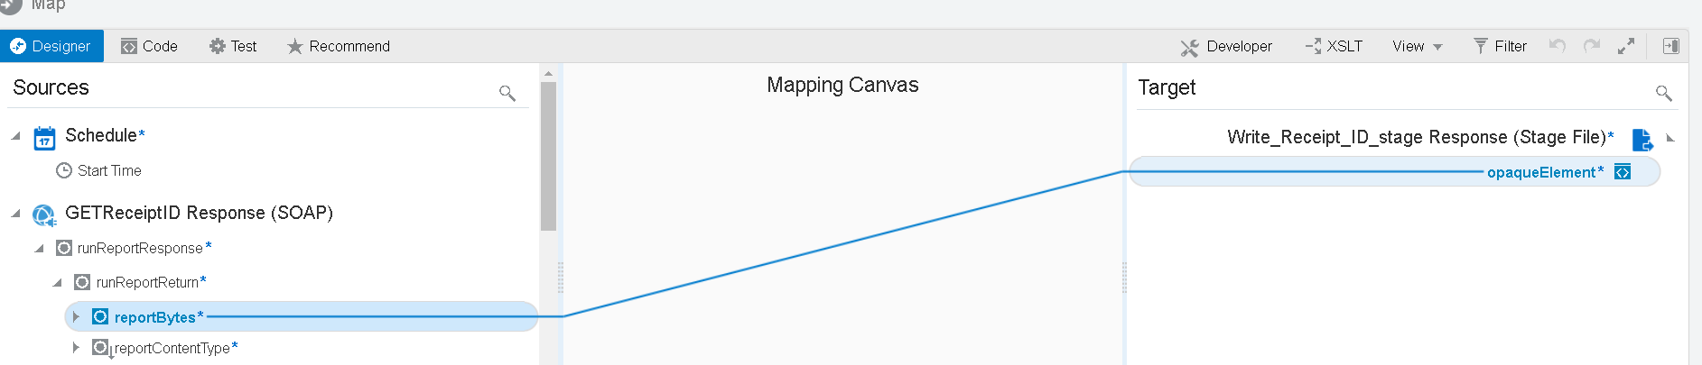
- Now we will use the stage activity to read the file from the response of the download_ftp.
- Search for ‘stage’ adapter by clicking on the plus (+) icon.
- Select the operation as ‘Read Entire File’. And configure file reference as yes.
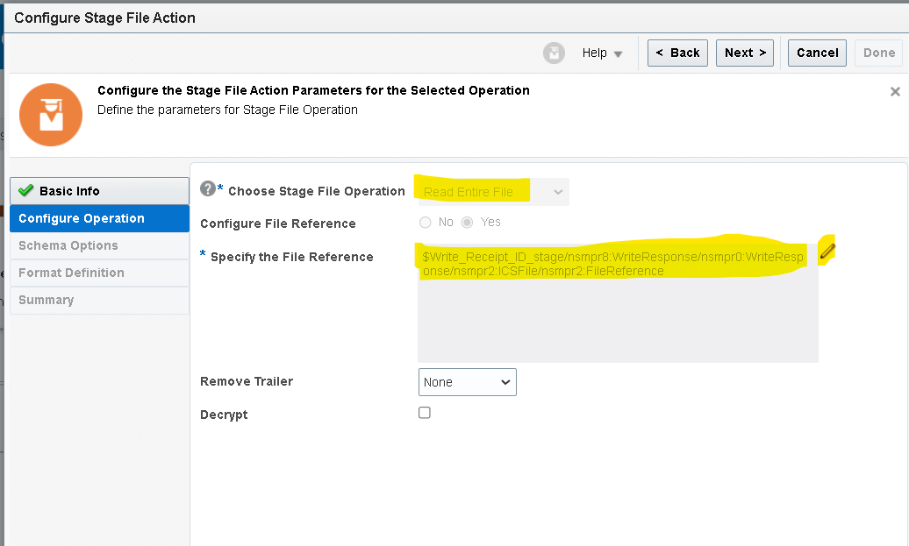

- Now we need to give the structure of the file content. As we are using the csv file select reference file from Write File response.
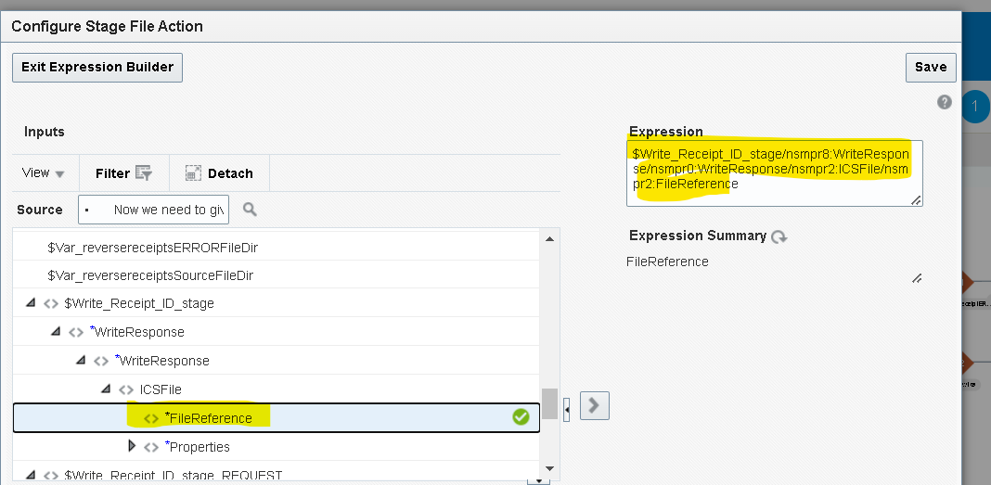
- We need to give sample structure format of the file which we will be report output format.
- Here choose the file from your local desktop and you can mark all as optional but at least one column should be mandatory.
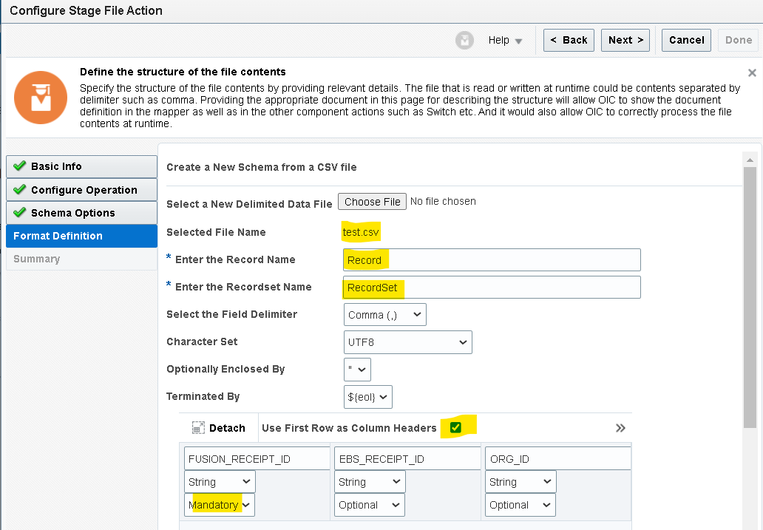
- Check the summery details and click on Done.
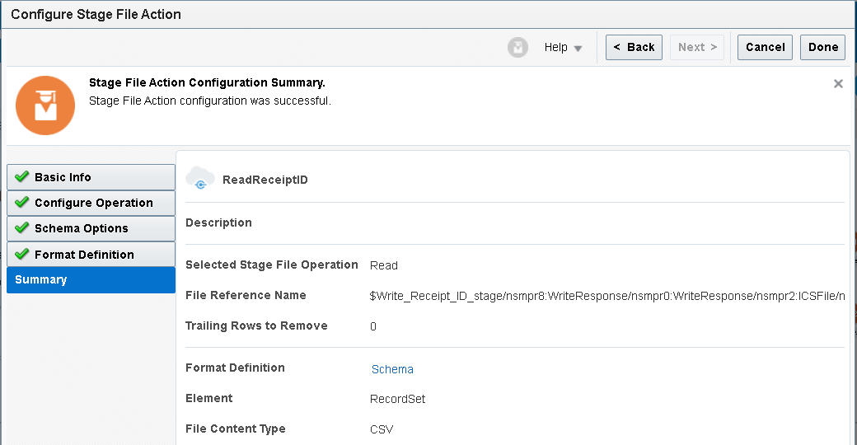
- After read file operation we need to use for each to iterate the each record of the file
- Here we will iterate the each record from the response of the ReadSourceFile_Stage.

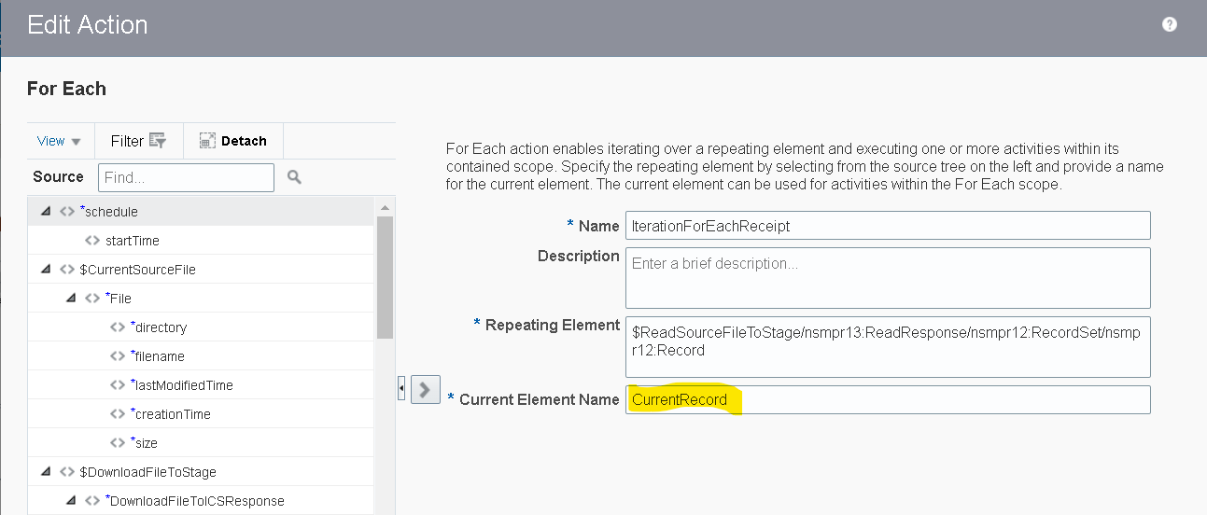
- Now here we will add one more scope for the each record.
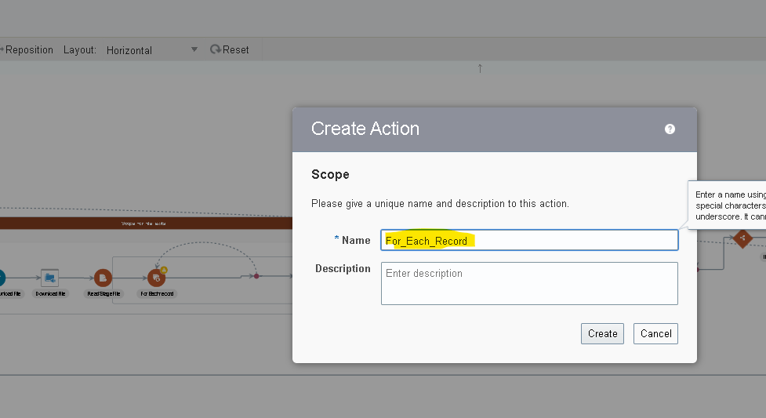

- Search for the SOAP adapter to Apply AR Receipts which we created earlier.
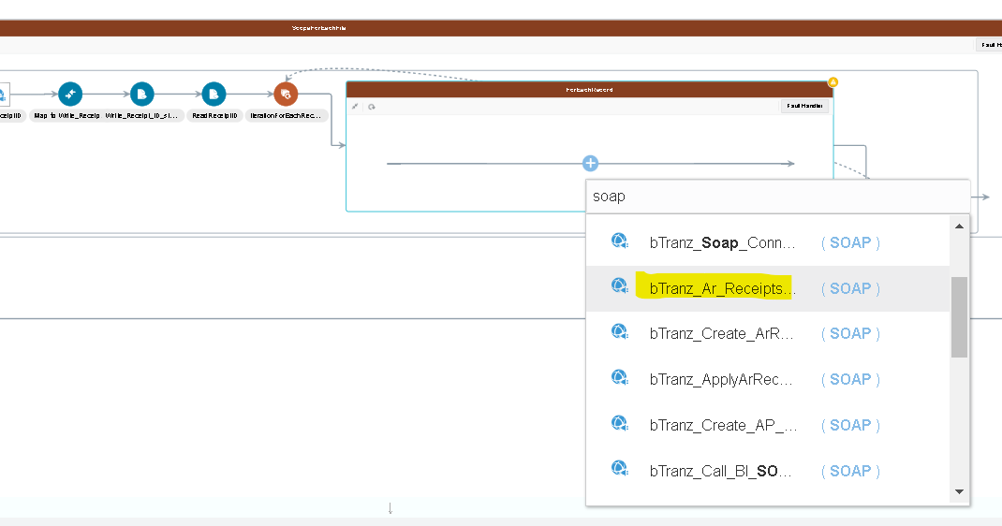
- Provide a name for the endpoint and select next.
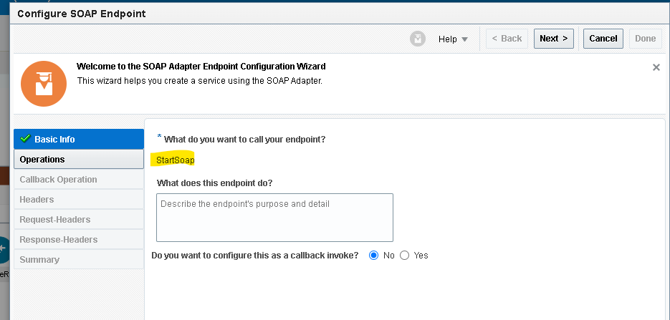

- Select Operation as CreateApplyReceipt and check the summary details and click on Done.
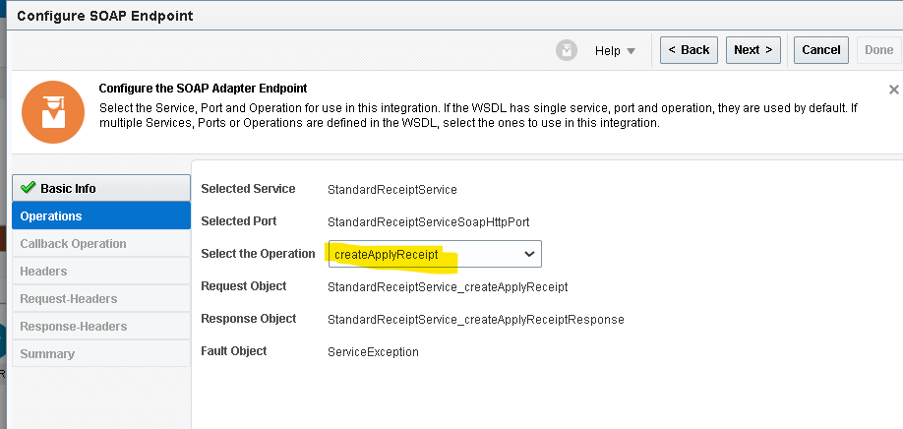
- Mapper will create automatically for the SOAP adapter click on the mapper and edit.
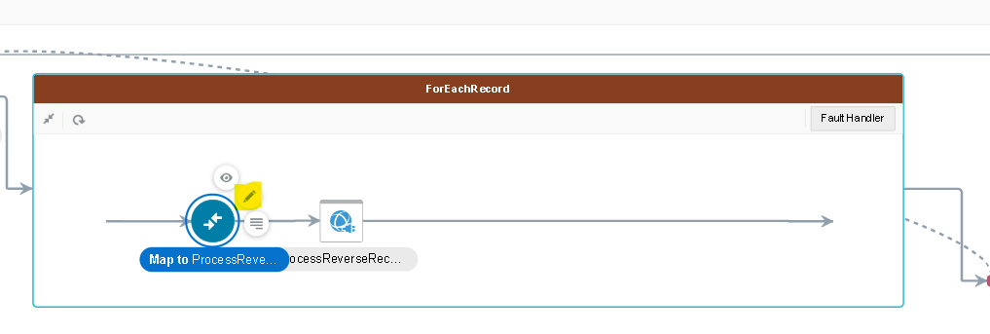

- We used XPath to compare ebs_cash_receipt_id from current record and ReadReceiptID Response and assigned fusion_receipt_id to the SOAP payload. Map the remaining fields from Current record and click on validate and close.
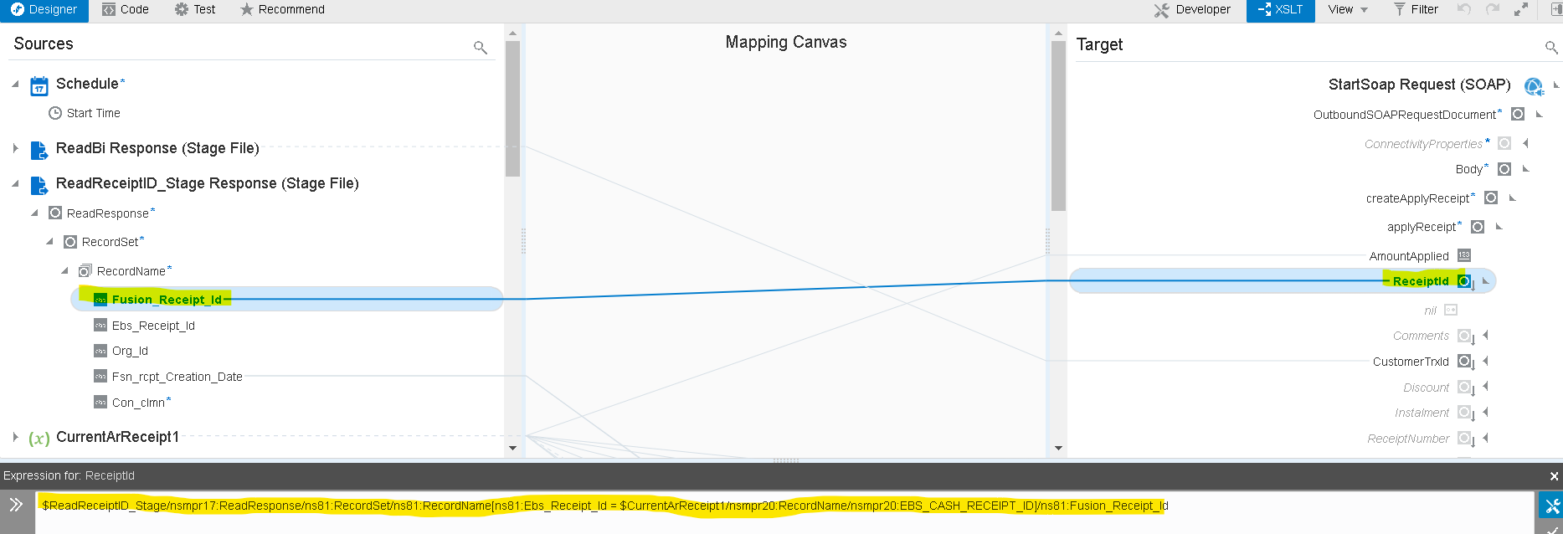
- We used XPath to compare ebs_Trx_ID from current record and Read_Trx_ID Response and assigned fusion_ Trx_ID to the SOAP payload. Map the remaining fields from Current record and click on validate and close.
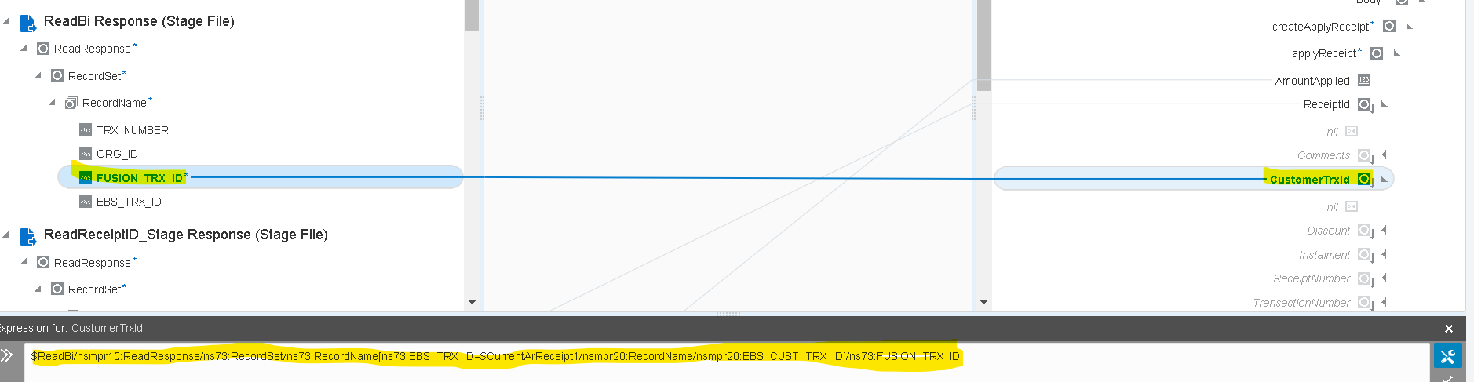
- Here we need to add another condition if fusion receipt creation date is greater than the current record apply date then we need to assign the fusion receipt creation to the application date or else need to assign the current record apply date to the application date of Soap Request.
- We used Choose and otherwise XLST function to compare the values. To assign Fusion receipt creation date to application date. In when condition we compared APPLYDATE < Fsn_rcpt_Creation_Date.
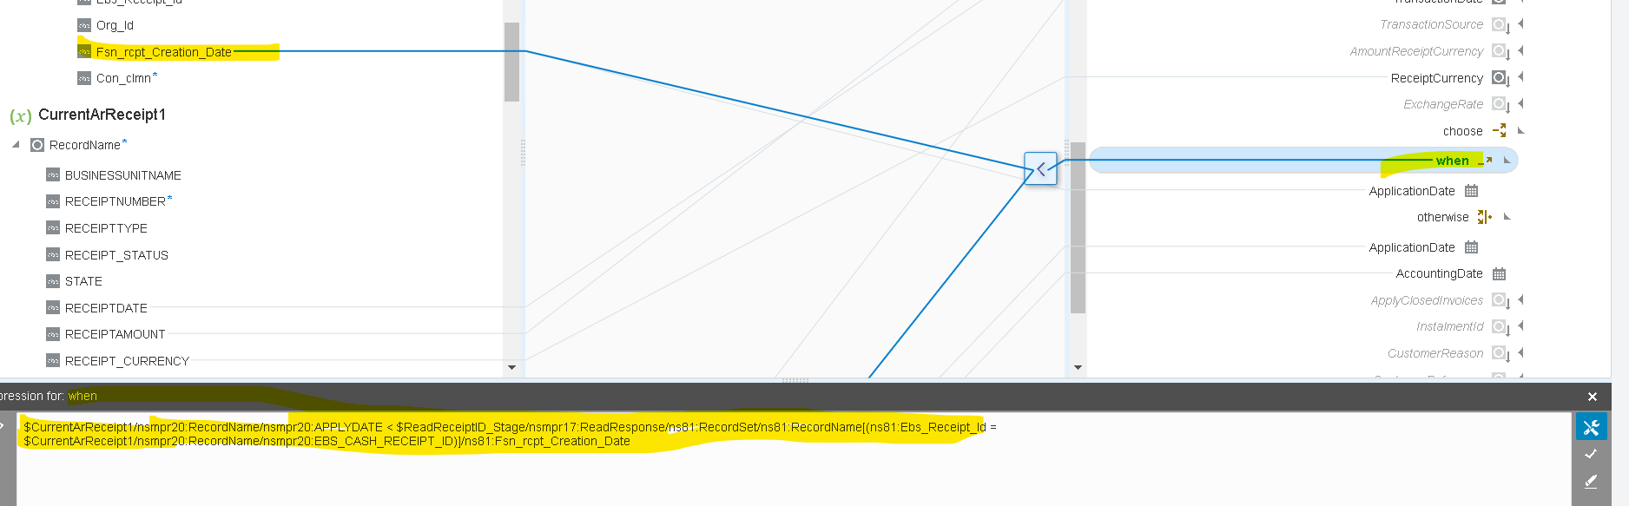
- Assigned fusion receipt creation date.
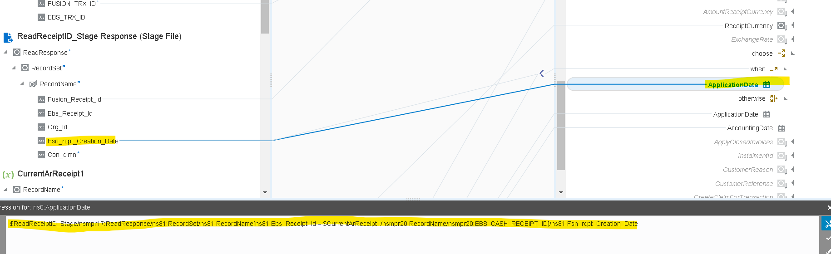

- In otherwise we mapped application date to current apply date. . Map the remaining fields from Current record and click on validate and close.
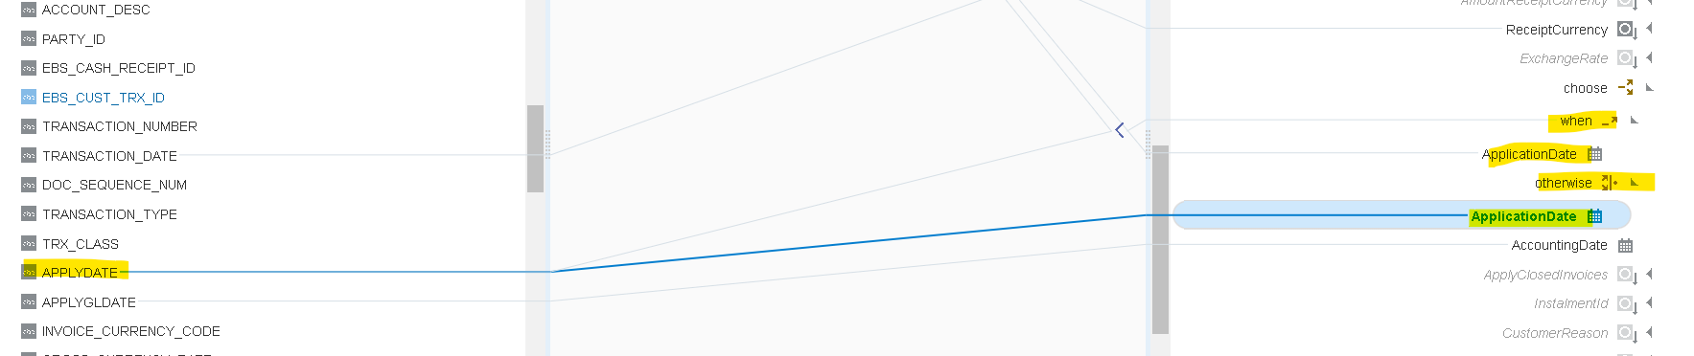

- Now we are using the stage write operation of the stage activity to update the FileReference variable with status and Error_Message columns.
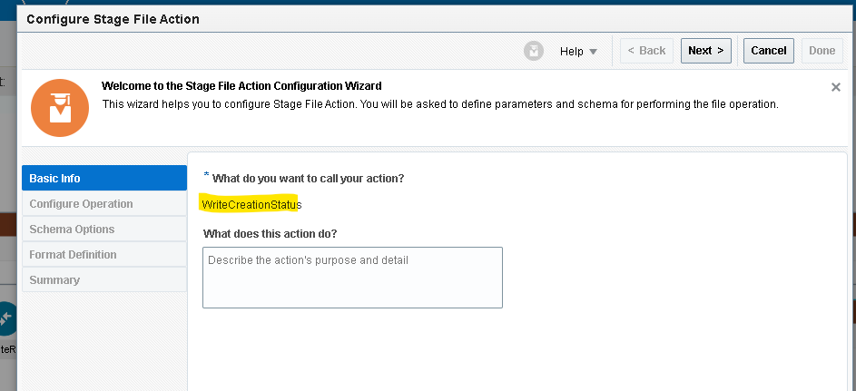
- Choose the file operation as writefile.
- Specify the file name and output directoty to store the file tempararly.
- Here we are using the option append to existing file which appends the every record to the file.
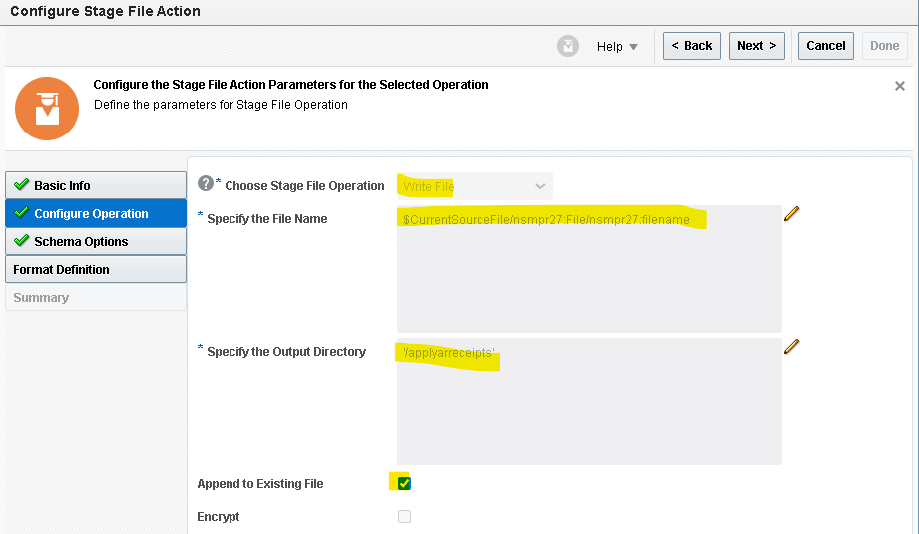
- Now we need to provide the structure of the file content here we are added two more columns in this file structure with ‘status and error message’.
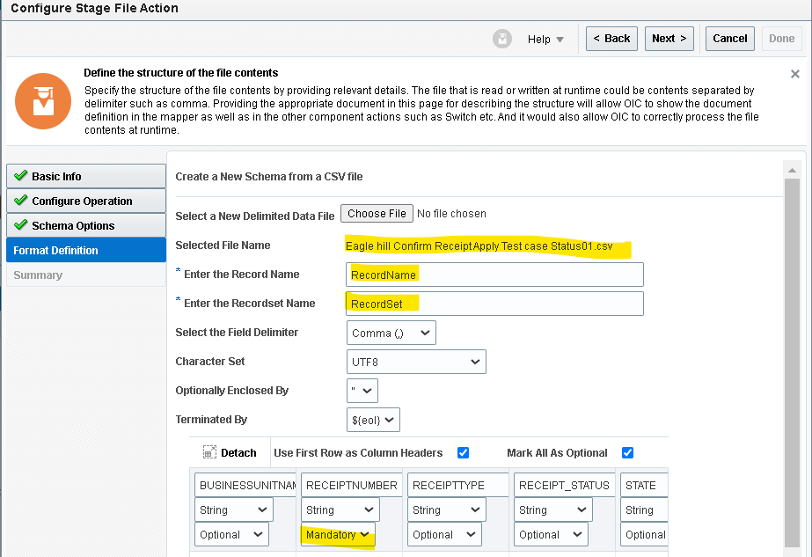

- Check the configuration and click on done.
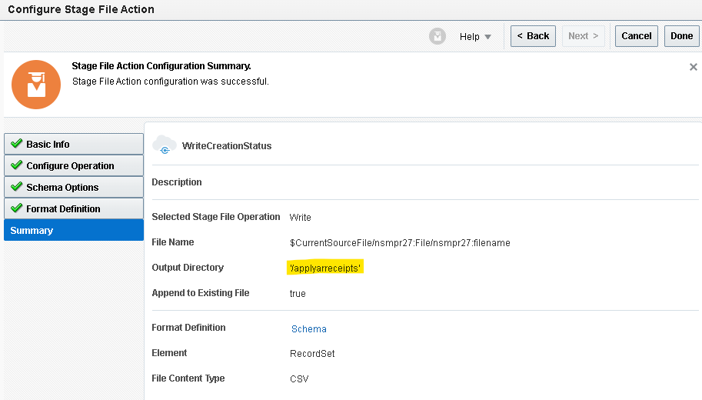
- Now edit the mapper of ‘write creation status’ map the current record columns to target fields and create a target node for the column status and hardcode with success.
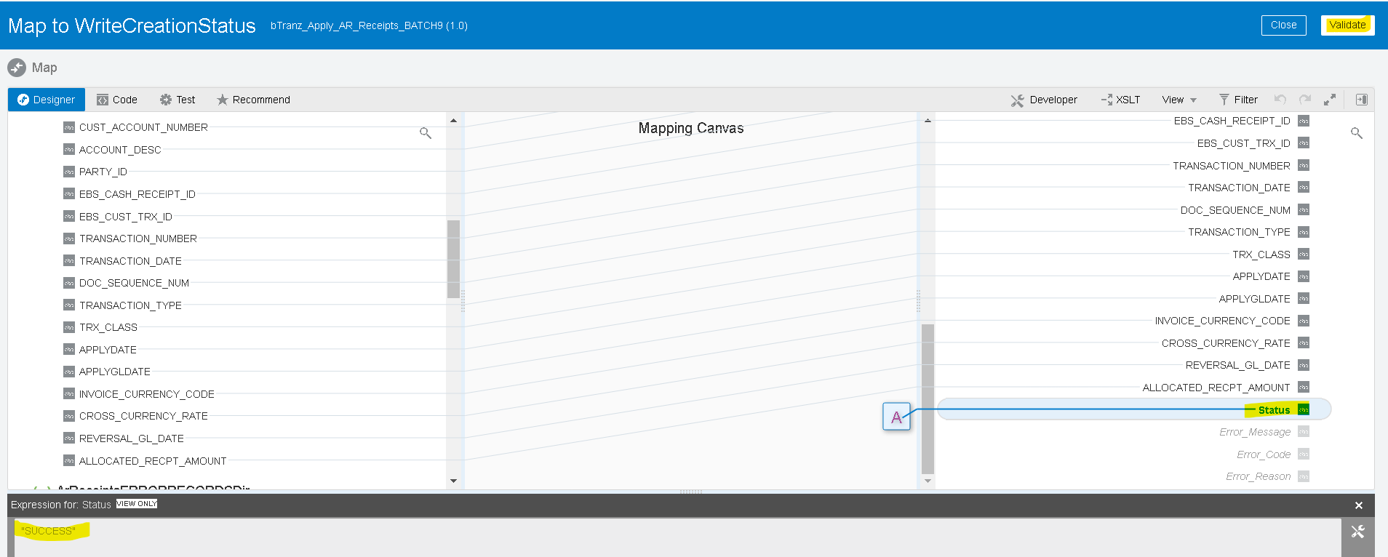
- Now we will update the ArReceiptsSUCCESSRECORDSref variable with the response of the WriteFile_Stage operation by using assign activity
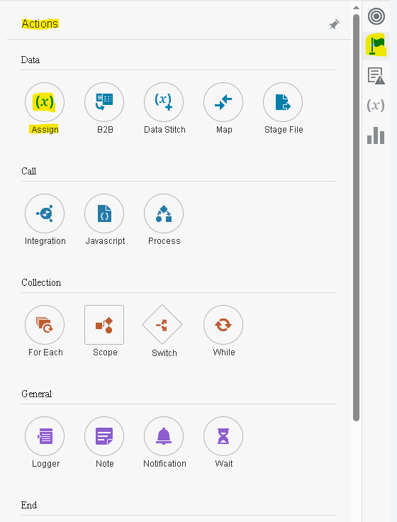
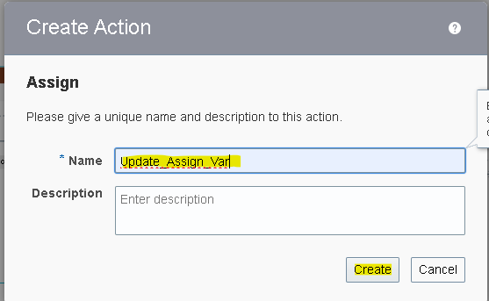
- By clicking on plus(+) icon it will create a variable then from the drop down select the variable which we want to update
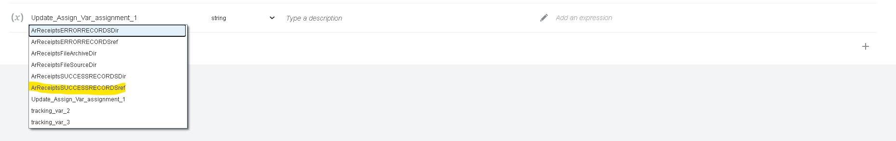

- Assign the FileReference from WriteCreationStatus response.
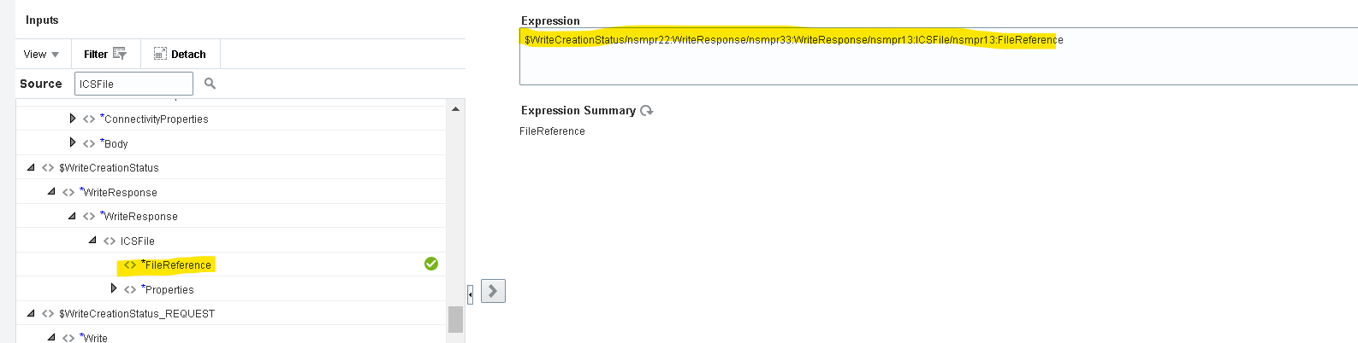
- Once you assign the FileReference click on validate and close.
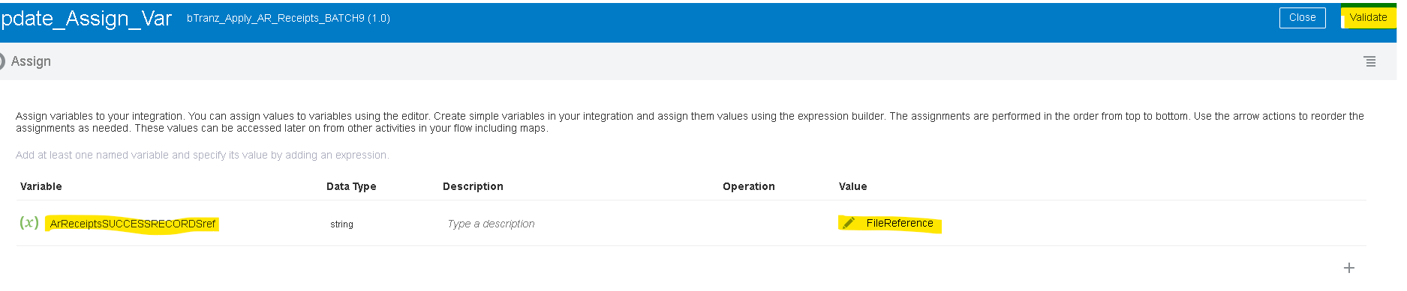
- Now we need to handle the fault handler for the ScopeForEachRecord.
- We will use default handler to be process if any error occurs.
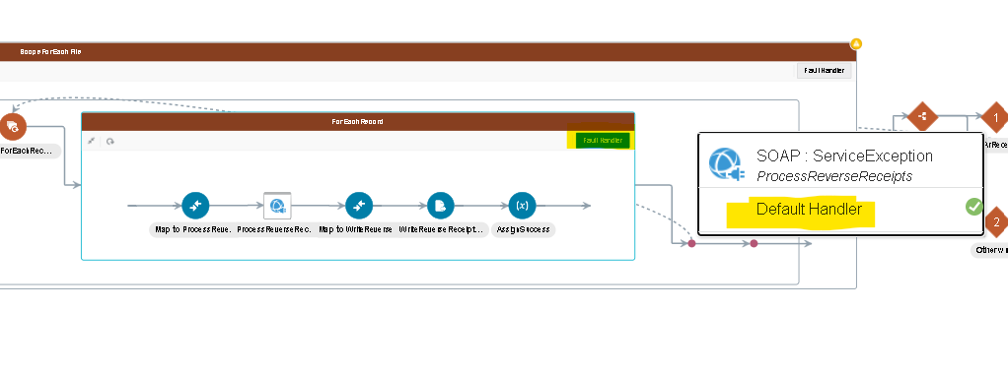
- Again we are using the stage activity to write the file (as done before for the success case) with status as ‘error’ and for error message we will map details of the ScopeForeEachRecordFaultObject details.
- Here we used substring function to get required part from error details.
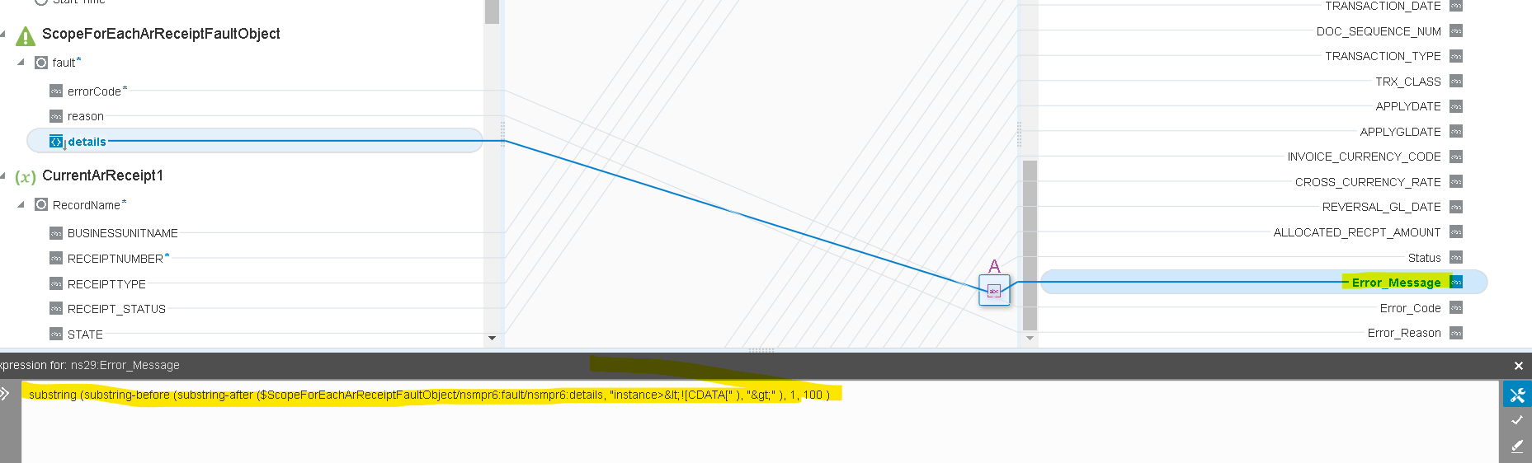
- Create a assignment variable and update the Var_ArReceiptERRORFileRef variable With FileReference of WriteCreationStatusError response.
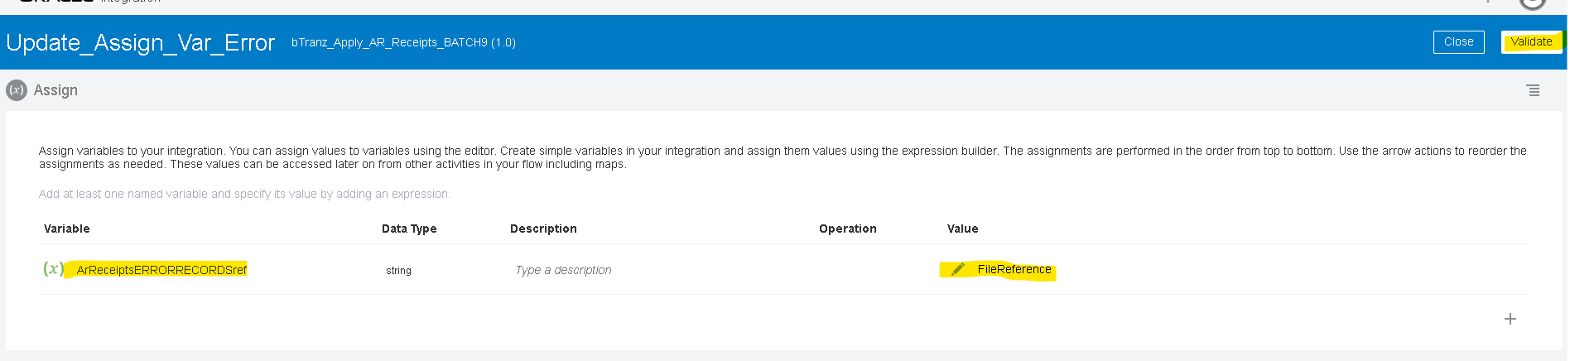
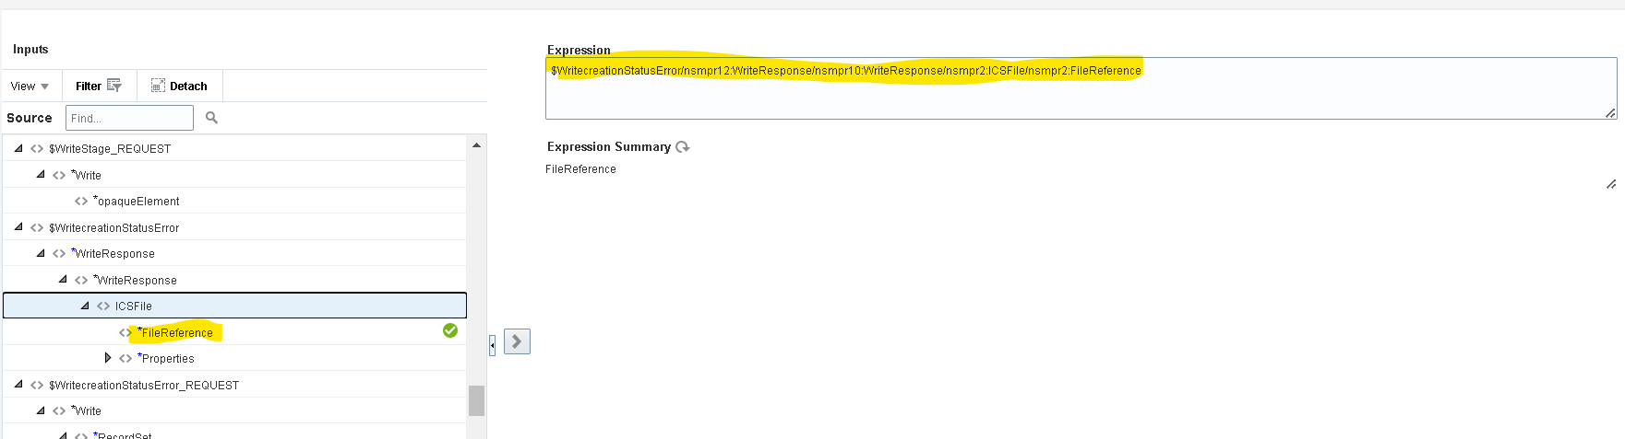

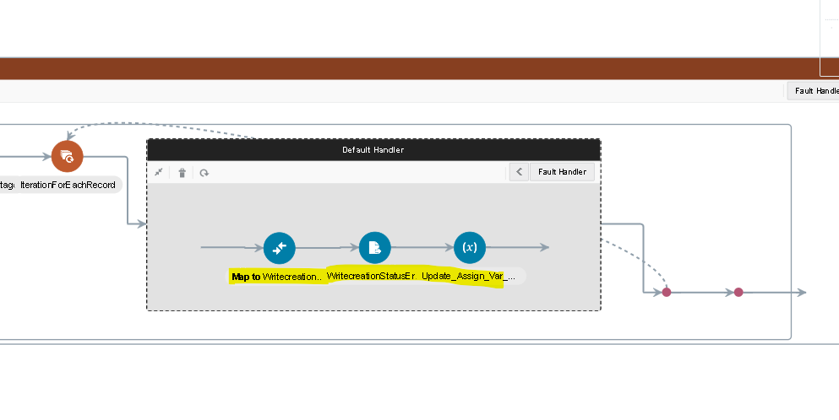
- We used Switch Operation to write into FTP server if there is any success records.
- Use $ArReceiptsSUCCESSRECORDSref!=’’ to check if there is any success records exists.
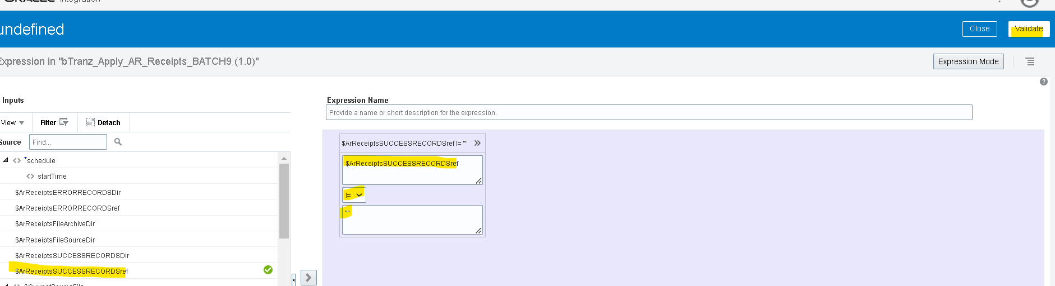
- Use the Stage Read adapter to read the SUCCESS records.
- ‘Select Read File in Segments’ file operation to read success file in segments and assign the $ArReceiptsSUCCESSRECORDSref as File Reference.
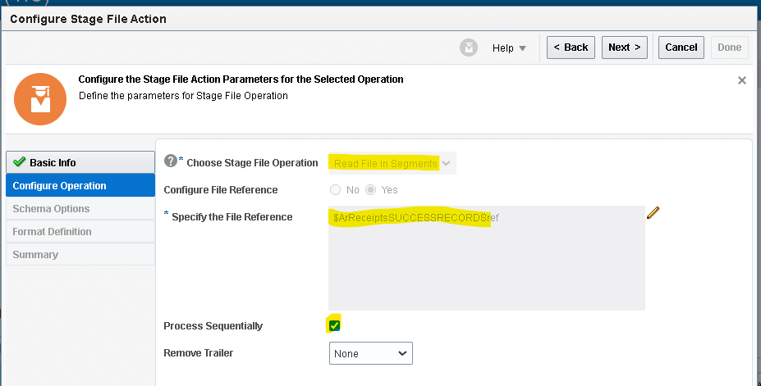
- Now We Need To Provide The Structure Of The File Content Here we unchecked the Use First Row As Colum Headers to read the first record as Data.
- Check the summery and click on done.
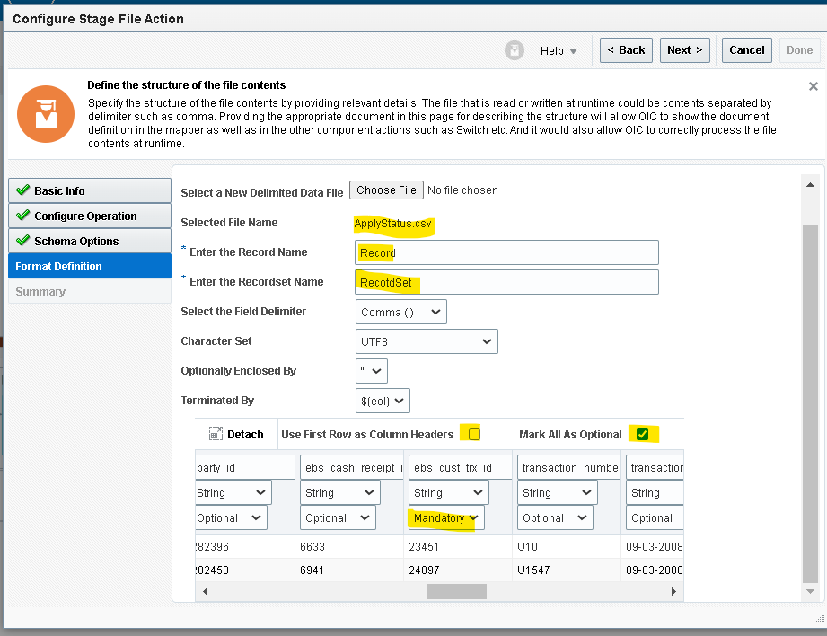
- Select FTP adapter that we created earlier and select Write File as operation.
- Since we can change File pattern and Output directory in mapping we can mention any temparory value.
- Check the Append to existing File to append all the records to the FTP file and click on next.
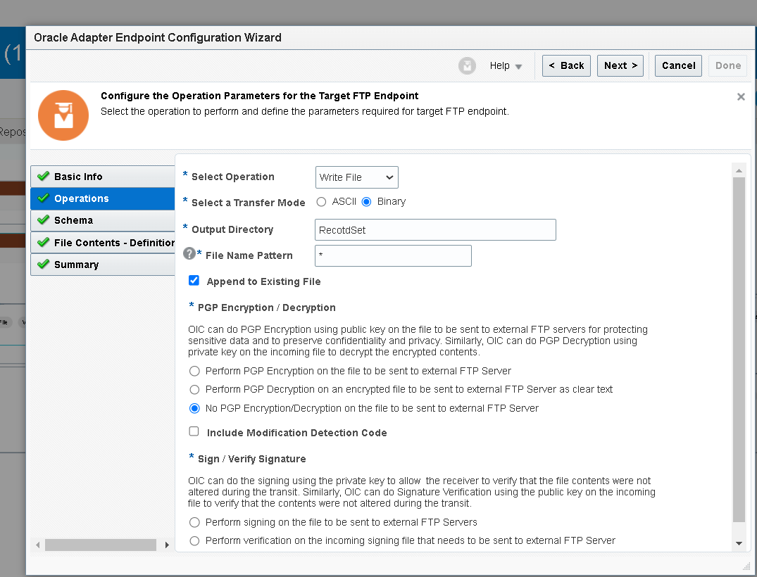’
- Now we need to provide the structure of the file content here we unchecked the use first row as colum headers to read the first record as record.
- Check the summery and click on done.
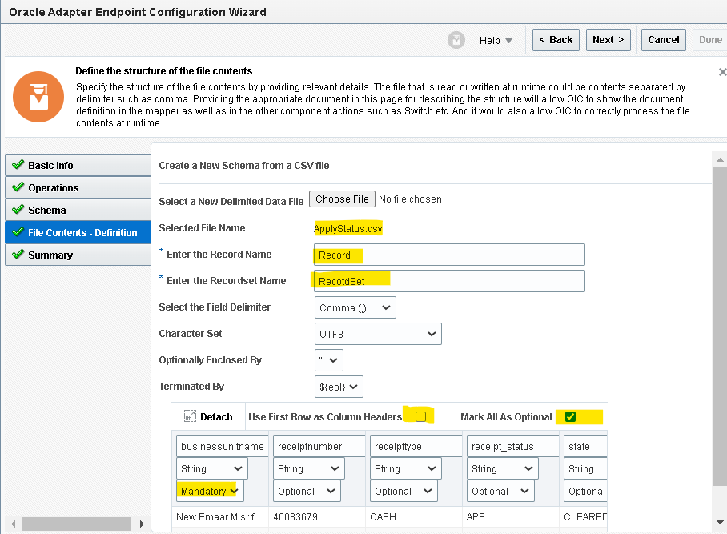
- Mapper will generate for FTP write operation. Edit the mapper and map ArReceiptsSUCCESSRECORDSDir to the directory and give a File name as per requrement ,map the remainig target fields from Read File segment response.
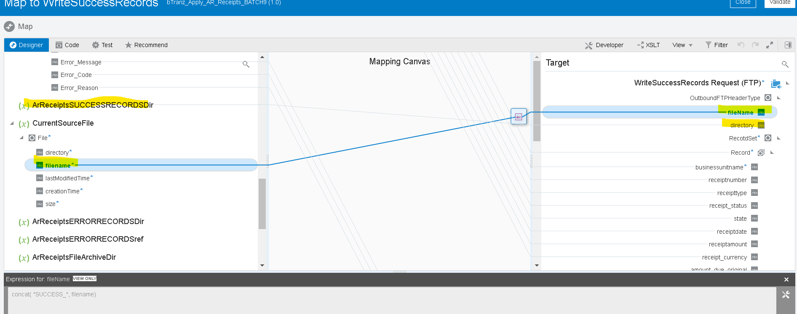
- We need to do the same for Error records too by checking the ArReceiptsERRORRECORDSref!=’’ condition in the switch operation and writing FTP file with Output directory as ArReceiptsERRORRECORDSDir
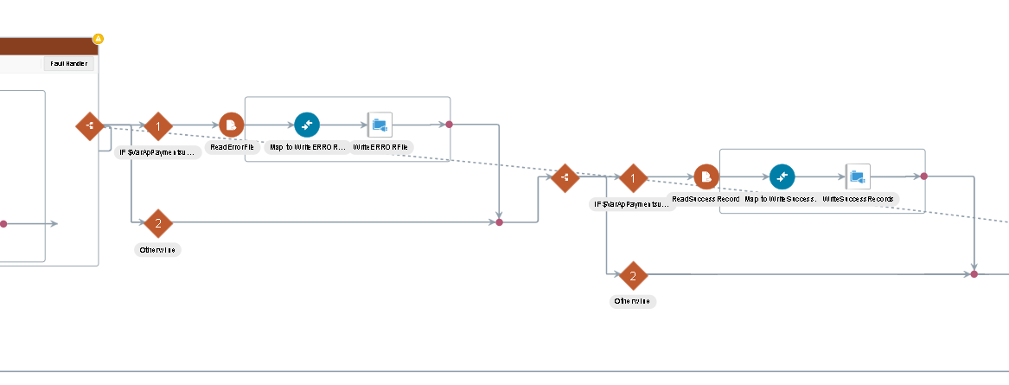
- Now we will use the notification activity to send a mail in message body we will send the InstanceId of the integration and Filename.
- Drag the notification action on the outside of both the scopes.
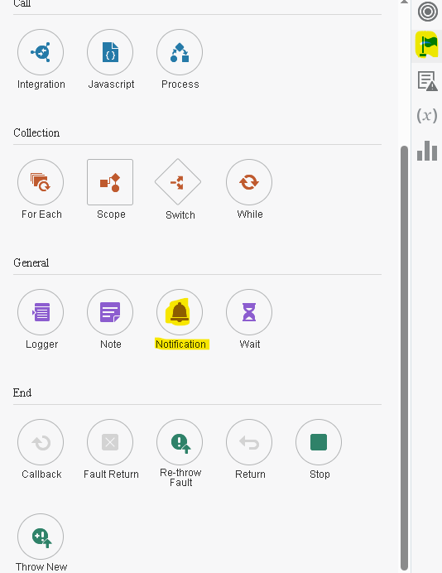
- You can provide the details as per your requirement.
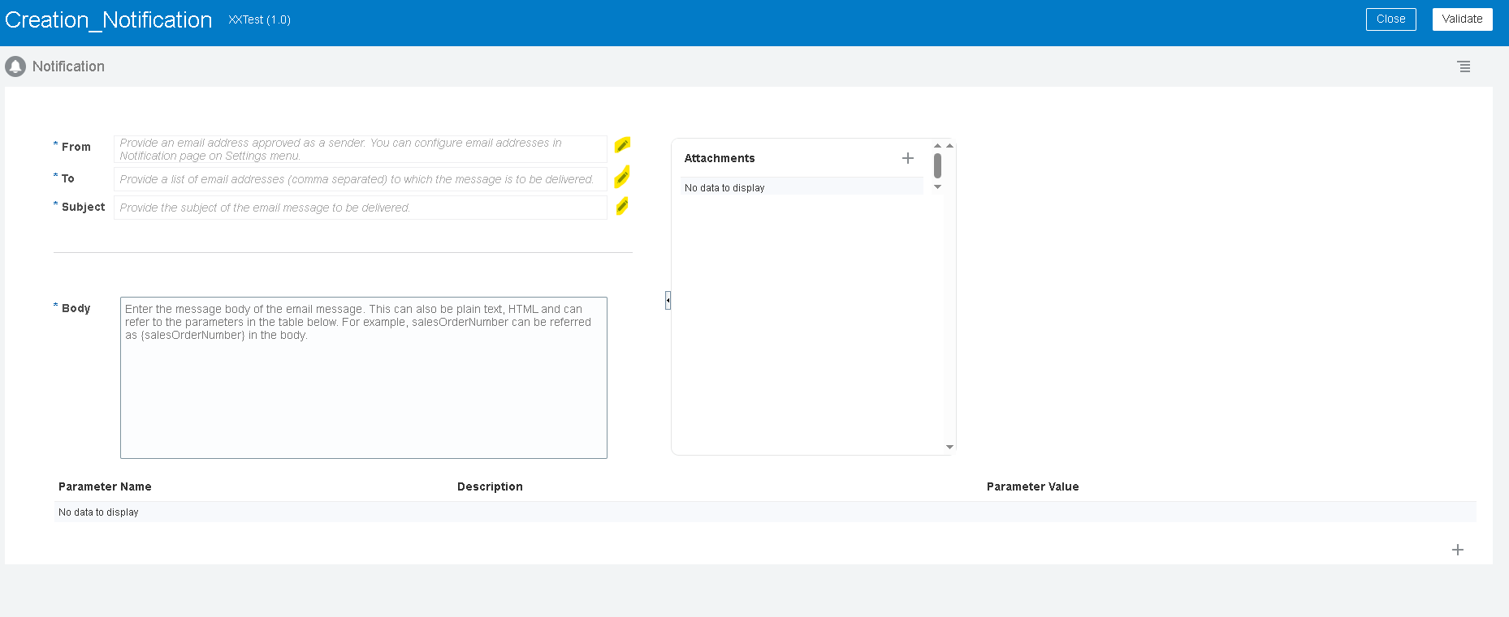
- In message body if you need to pass the InstanceId and filename you need to create a parameter and then you can use those parameters by enclosing with flower brackets as shown below.
- Once you enter all the details validate and close the notification.
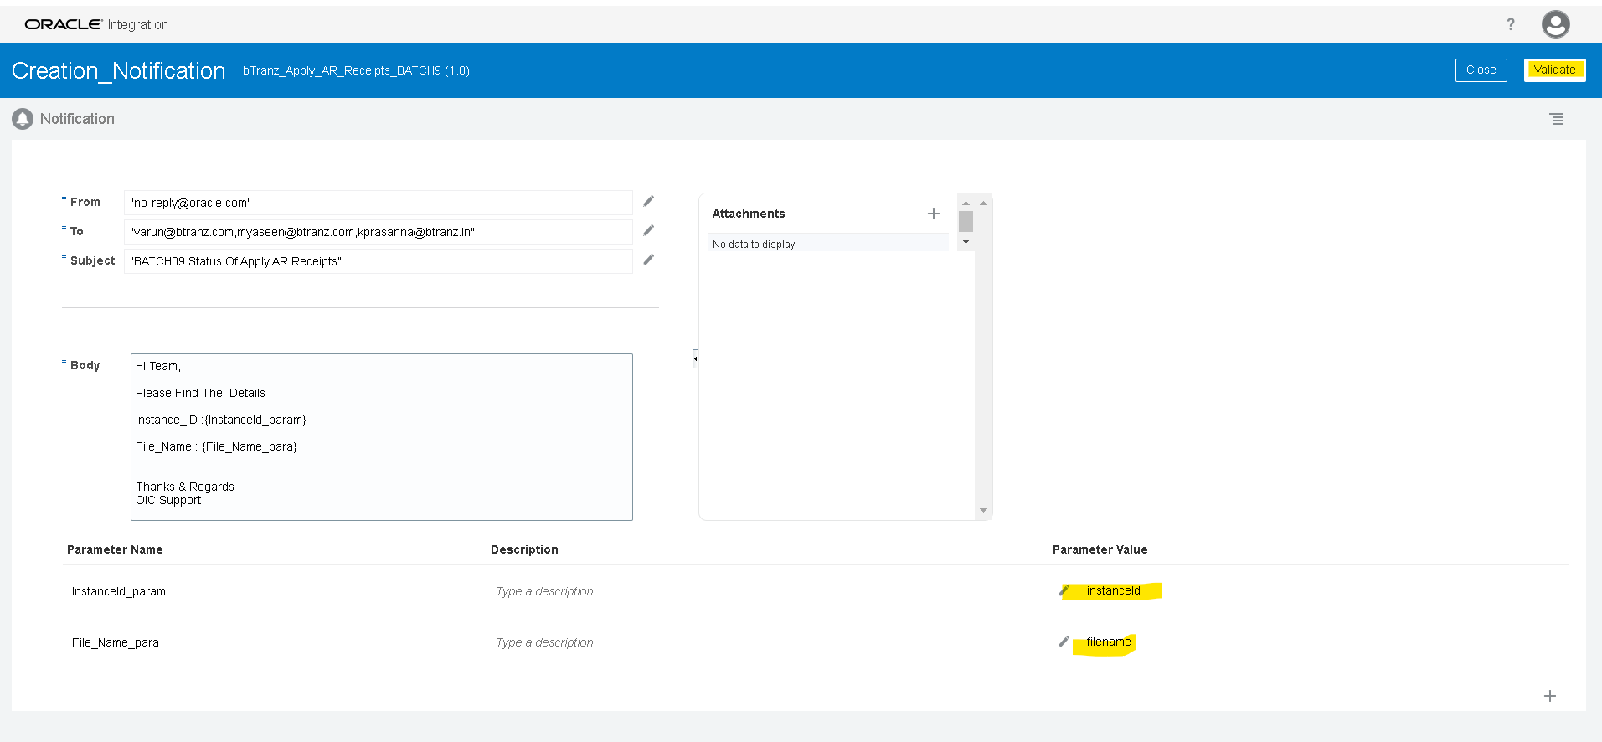
- Now we will move the file from in directory to archive directory using move operation of Fftp_Connection
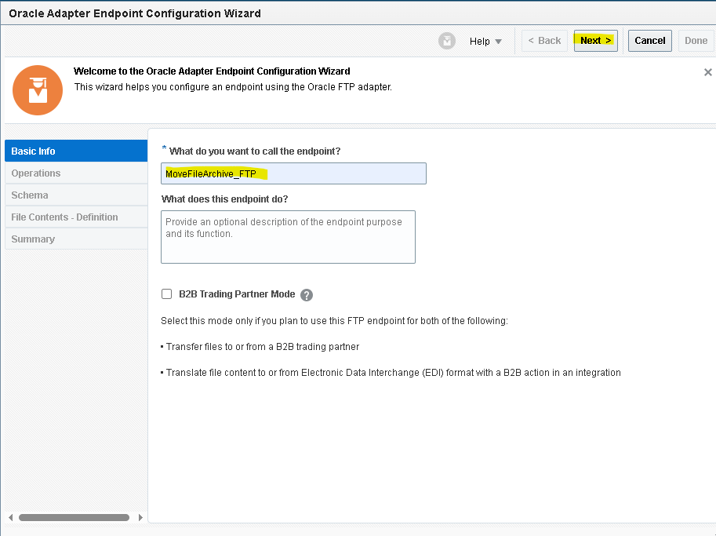
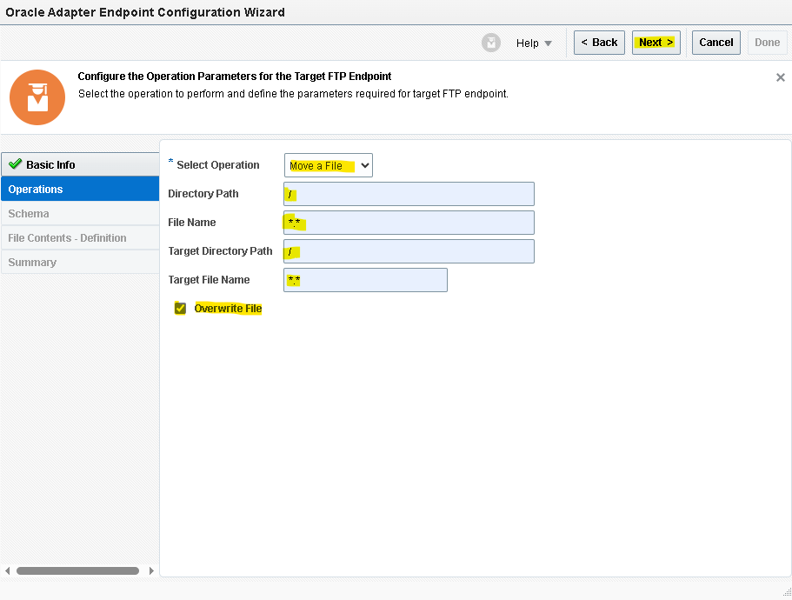
- Check the overwrite option as it removes the existing file and overwrite with new file in archive directory
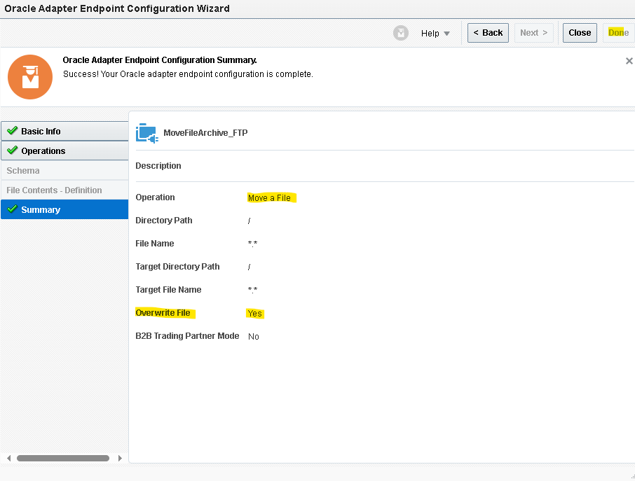
- We are having variables for in and archive directories we will map that variables to Directory and Target Directory respectively, Map the filename from CurrentSourcefile for both the filename and target filename
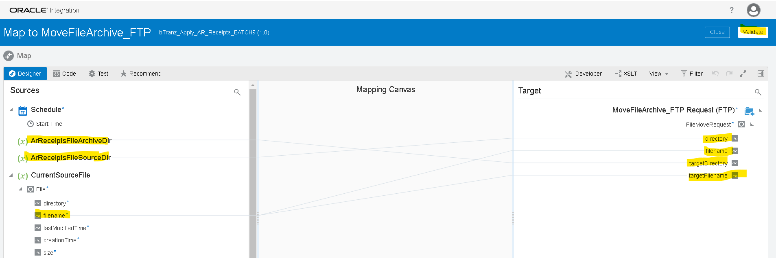

- For every integration we need to assign at least one tracking variable maximum we can assign up to three as it will be used when we are tracking the integration .here you can observe the error.
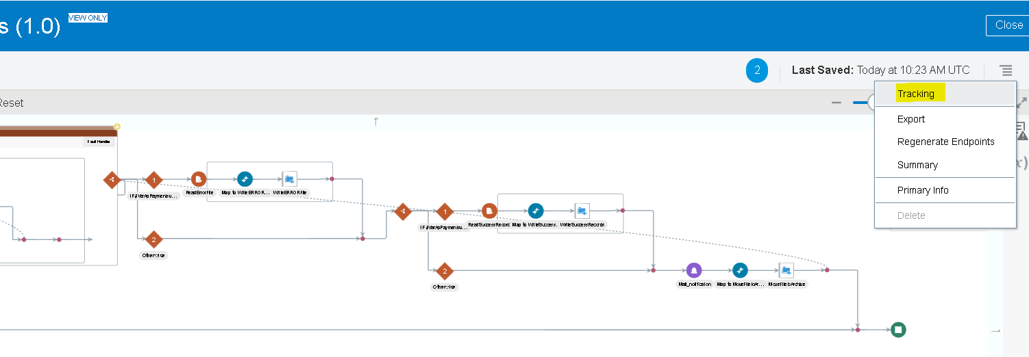
- Drag any variable from source to Tracking Field to mention it as Primary variable.
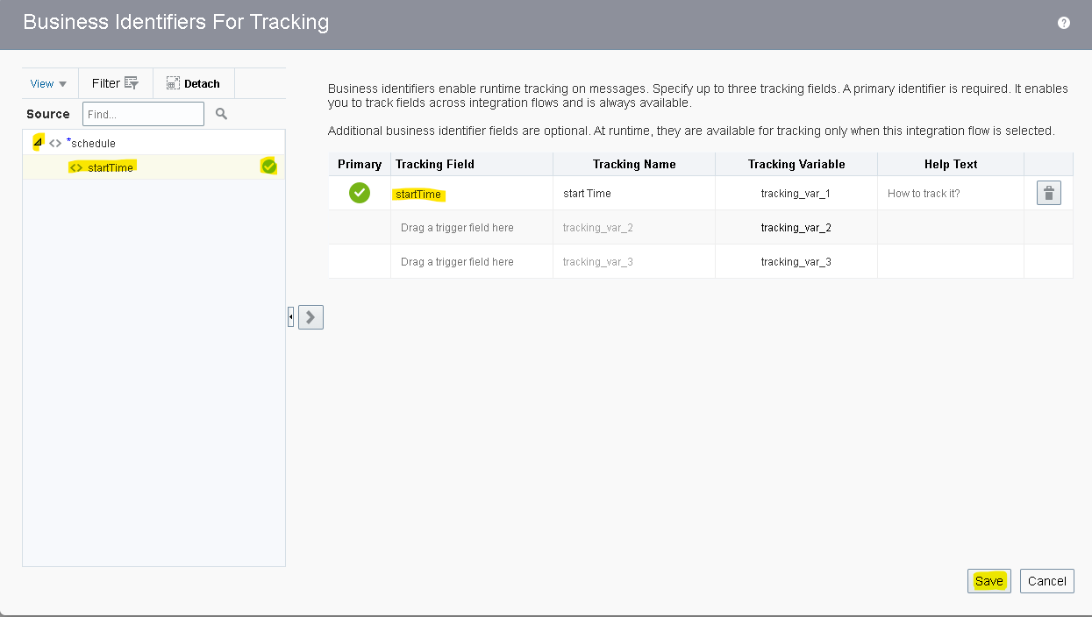
- Once you declare the tracking variable save and close the integration.
Running The Integration:

- Before running an integration we need to activate it initially it will be in draft state after successful creation it will be in configured state after activating it will be in active state.

- You can activate and schedule as per your requirement it will run or you can just activate directly.
- By checking include payload option it helps you to check the payload of each operation in tracking page.

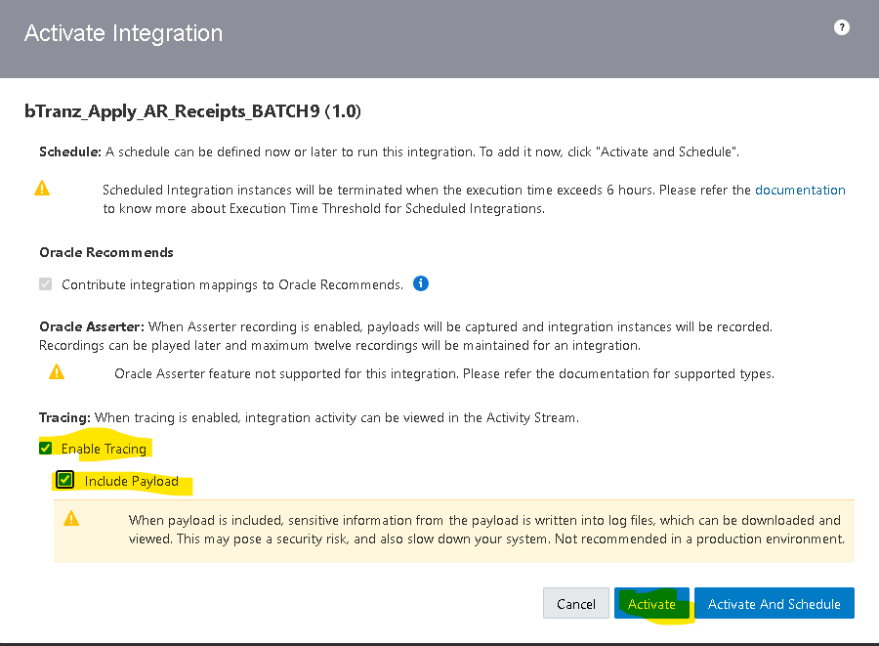
- By clicking on submit now option it will run the integration.
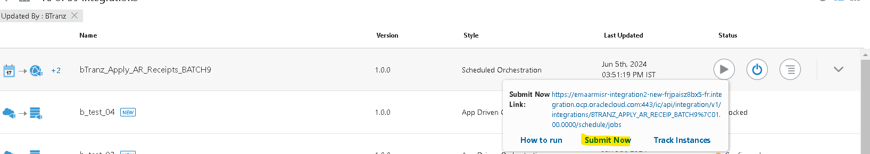
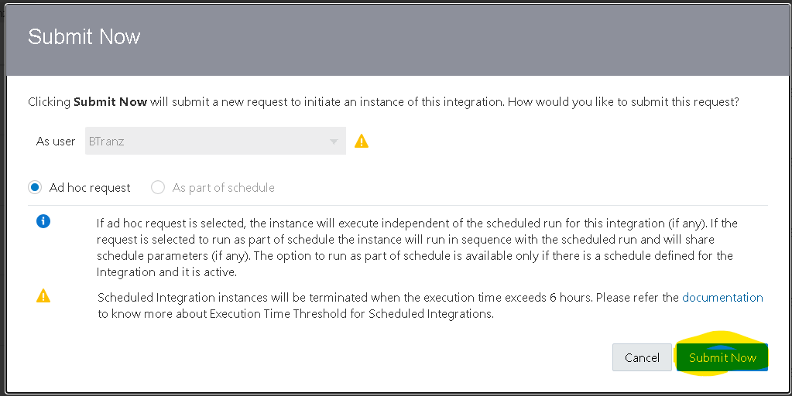
- You will get an InstanceId when you run the integration by clicking on that instance id you will be redirect to tracking page where you can check the status of that integration.
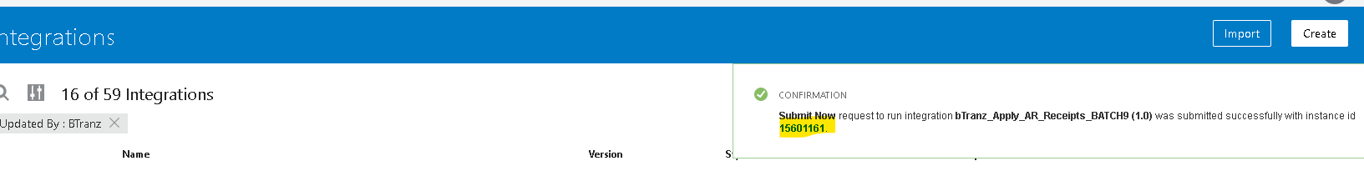

Tracking The Integration:

- To track the integration manually MonitoringIntegrationsTracking.

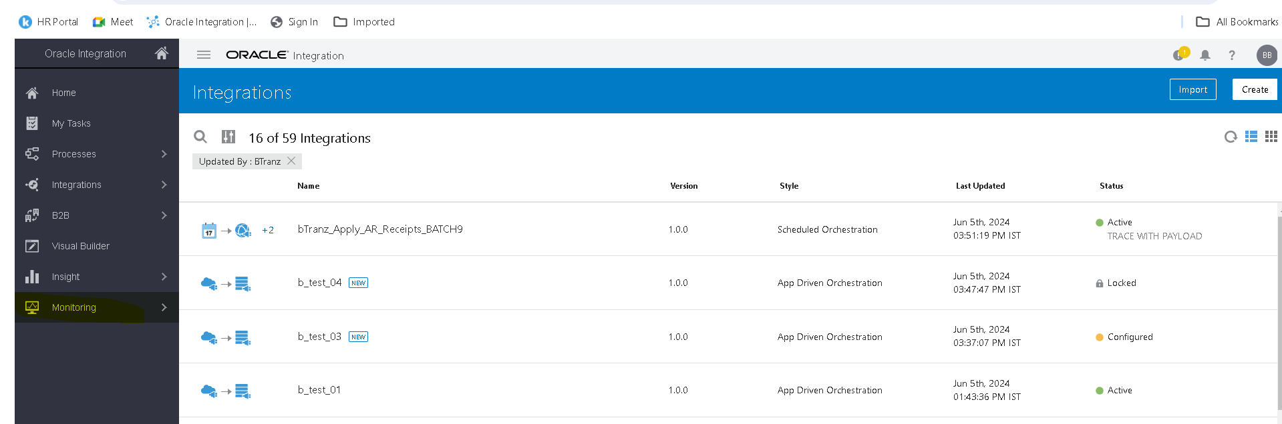
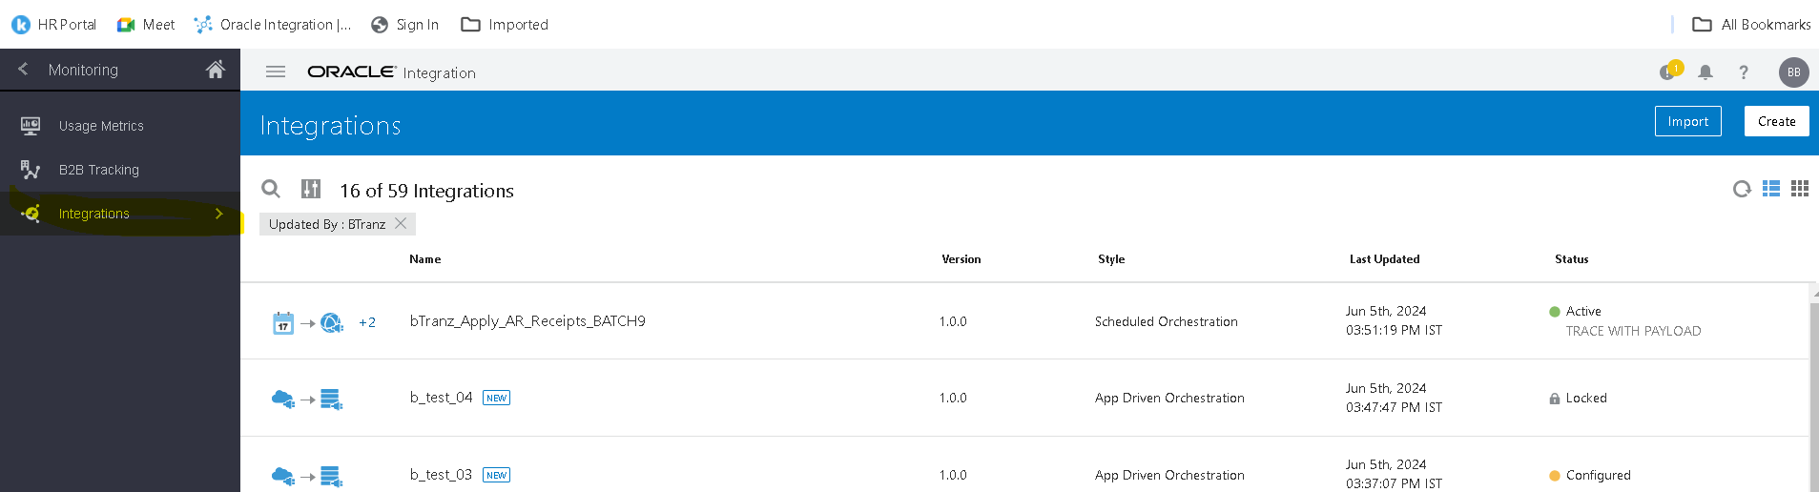

- Here you can observe the InstanceId and status of the integration (if you clicked on InstanceId while running the integration you will be redirected here)
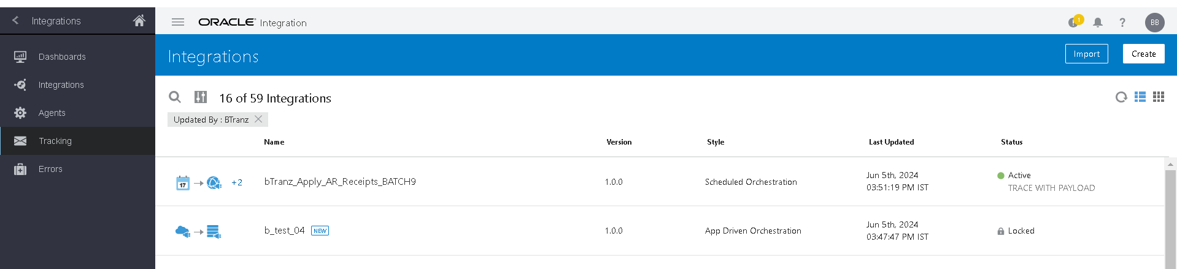
- By clicking on instance id in activity stream you can check the flow of the integration.
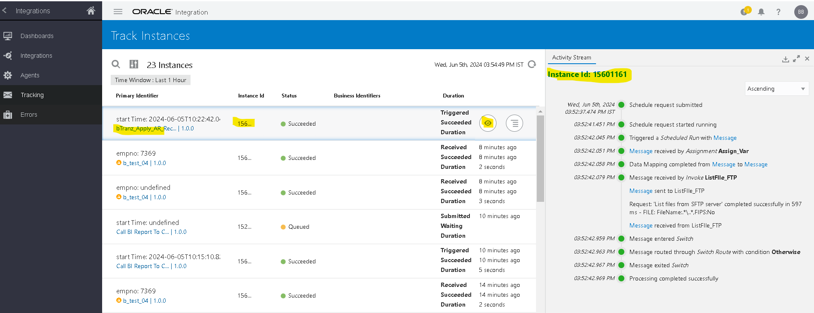

Open and Closed Issues for this Deliverable

Open Issues

ID | Issue | Resolution | Responsibility | Target Date | Impact Date

Closed Issues

ID | Issue | Resolution | Responsibility | Target Date | Impact Date

